FEATURED DEAL
Name: 1-800-GOT-JUNK

Offer Title: Members save 7% on junk removal.

Redemption URL: https://www.dpbolvw.net/click-7273667-13901274?sid=10834033

Short Description: It's never been this easy to remove unwanted items from your home or office. Just call or book online to schedule

Logo: https://static.accessdevelopment.com/brand/afd886be8a09effc6e651c03acb58ce4355ee74a/original.png
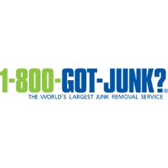
Expiration Date: 1/31/2026

T&C: Powered by Access. Offer may not be valid with other sales/promotions. Void if altered, transferred, purchased or sold; use for these purposes is illegal and constitutes fraud. Other restrictions may apply. Offers are subject to change without notice. © Access Development. All rights reserved. www.accessdevelopment.com

