FEATURED DEAL
Name: Chicago Steak Company

Offer Title: Receive 4 Free 8oz Ribeyes with Your Order of $159+

Redemption URL: https://fmtc.co/48114437/d99f47ec361410ac5ecb5c798fb641d1?sid=ADD_CVT

Promo Code: 4RIBEYES

Short Description: At Chicago Steak Company, we invite you to taste tradition. Since 1865 with the founding of the Union Stock Yards, Chicago has been at the heart of high-quality American meats. Chicago Steak Company proudly carries on that tradition. We specialize in hand-cut, Mid-West raised, USDA Prime beef - in short, the very best steaks your money can buy. We raise, trim, and age our steaks using centuries-old techniques, then vacuum-seal each individually, locking in flavor and freshness.

Logo: https://static.accessdevelopment.com/brand/046c85aaf17a70ac04ab1dade25aeb8d64f9c0dc/chicagoSteakCo-30367093-300x300.png
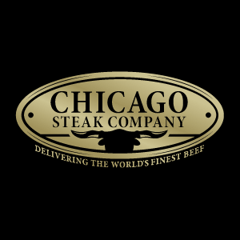
Expiration Date: 12/31/2025

T&C: Terms and Exclusions Apply, See Site for Details. Powered by Access. Valid only at the location listed. Only one offer may be redeemed per visit. Offer may not be valid with other sales/promotions. Void if altered, transferred, purchased or sold; use for these purposes is illegal and constitutes fraud. Other restrictions may apply. Offers are subject to change without notice. No cash value. © Access Development. All rights reserved. www.accessdevelopment.com

