FEATURED DEAL
Name: Electrolux

Offer Title: Up to 50% off + Free Delivery.

Redemption URL: https://www.electroluxfamilystore.com/en/login/register/affiliate/Access%20Development?utm_source=Access+Development&utm_medium=referral&utm_campaign=Access+Development

Short Description: Electrolux is determined to eliminate the barriers that prevent you from making more sustainable choices for your home appliances. Through exclusive access to The Family Store, Electrolux is offering up to 50% off appliances plus free delivery on all orders.

Logo: https://static.accessdevelopment.com/brand/62d4ffc2fc57e7b48257c687d2c24051843ae3c1/Electrolux_Logo_300x300.png
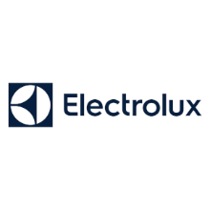
Expiration Date: 12/31/2025

T&C: Product availability may vary by region. Home delivery, installation, and haul away options are only available in select US markets. Pricing information from The Family Store website is confidential and intended for users of this program only. Offer subject to change. Powered by Access. Offer may not be valid with other sales/promotions. Void if altered, transferred, purchased, or sold; use for these purposes is illegal and constitutes fraud. Other restrictions may apply. Offers are subject to change without notice. No cash value. © Access Development. All rights reserved. www.accessdevelopment.com



