FEATURED DEAL
Name: GlassesUSA

Offer Title: 40% off frames inc designers, plus free Rx lenses & free shipping.

Redemption URL: https://glassesusa.7eer.net/c/24547/2182240/1546

Promo Code: ACCESS40

Short Description: GlassesUSA.com is the fastest growing, leading online eyewear retailer in the US offering a variety of high-quality designer brands and established house brands in a wide-range of styles – single vision glasses, multifocals, sunglasses, sports glasses, kids glasses, contact lenses, digital protection and more - GlassesUSA.com was built on the belief that purchasing eyewear shouldn't break the bank and is on a mission to change the way consumers purchase eyewear.

Logo: https://static.accessdevelopment.com/brand/911f783edd6bed325326193591090258f08b7e61/GlassesUSA_Logo.png
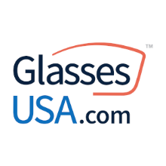
Expiration Date: 12/31/2025

T&C: Includes designer brands & in-house collections. Excluding: Ray-Ban, Oakley, Persol, Costa Del Mar, Prada, Luxury, and Contact lenses. Offer may not be valid with other sales/promotions. Void if altered, transferred, purchased or sold; use for these purposes is illegal and constitutes fraud. Other restrictions may apply. Offers are subject to change without notice. No cash value. © Access Development. All rights reserved. www.accessdevelopment.com

