FEATURED DEAL
Name: Hard Rock Cafe

Offer Title: 15% Off Catering Orders.

Redemption URL: https://cafe.hardrock.com/catering.aspx

Promo Code: AccessApp

Short Description: Take center stage while being immersed in a world of music, iconic memorabilia, and of course – delicious food. Receive the Rock Star treatment while enjoying a mouth-watering menu that is home to our famous Legendary® Burger, luscious libations, and more.

Logo: https://static.accessdevelopment.com/brand/f93574ab5ddabd68e4259d7b45e1b6e6a8c62181/HardRockCafe_Logo_300X300.png
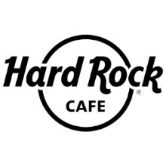
Expiration Date: 12/31/2025

T&C: Offers have no cash value, except where required by law, and cannot be combined with any other offers or discounts. Hard Rock Cafe reserves the right to cancel or change offers without notice. Other restrictions may apply. Powered by Access. Only one offer may be redeemed per visit. Offer may not be valid with other sales/promotions. Void if altered, transferred, purchased, or sold; use for these purposes is illegal and constitutes fraud. Other restrictions may apply. Offers are subject to change without notice. No cash value. © Access Development. All rights reserved. www.accessdevelopment.com
