FEATURED DEAL
Name: PODS

Offer Title: 10% off a local move.

Redemption URL: http://www.pods.com/access

Promo Code: ACCESS

Short Description: PODS offers you a cost saving and convenient alternative to moving and storage of you household goods. Whether you're moving across town or across country, we provide you with a level of control and flexibility traditional moving and truck rental companies just can't compete with. You decide when and where you want the container delivered, picked up and delivered to your new destination. We can also store your goods in one of our centrally located, secure and accessible storage centers for extremely cost effective short or long term storage. PODS can also provide labor services to help pack, load and unload, as well as ship moving supplies and boxes right to your door. We can even arrange to have your car transported.

Logo: https://static.accessdevelopment.com/brand/4dbce8dd64d31f88b46ecc9dbeaf71b83d824da4/Pods_logo_300x300.png
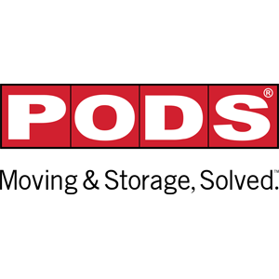
Expiration Date: 1/31/2026

T&C: Offer void where prohibited by law. Must mention promotional code at time of order. Additional mileage charges may apply if outside our standard delivery area. Please call 1-866-846-0900. For local moves, 10% off initial local delivery and first month's storage. Powered by Access. Valid only at the location listed. Only one offer may be redeemed per visit. Offer may not be valid with other sales/promotions. Other restrictions may apply. Offers are subject to change without notice. No cash value. © Access Development. All rights reserved. www.accessdevelopment.com

