FEATURED DEAL
Name: Papa John’s

Offer Title: 20% off regular menu price online orders.

Redemption URL: https://www.papajohns.com/

Promo Code: 20OFFAD

Short Description: Papa John's really delivers, because we are focused on quality pizza. And it starts with our Better Ingredients, like our fresh, never frozen, original dough, all natural-sauce, 100% real meats and fresh-sliced veggies. And, we think you'll taste the difference, because "Nobody does what Papa John's does." Order online today and use your pizza discount! We always have pizza specials and deals.

Logo: https://static.accessdevelopment.com/brand/eea60774d245f4dabad6647a738e3685f1ee7da5/PJ_Logo_300X300.png
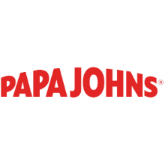
Expiration Date: 12/31/2025

T&C: Offer good online only for regular menu price items for a limited time at participating U.S. Papa Johns restaurants. Not valid with any other coupons or discounts. Limited delivery area. Delivery fee may apply and is not subject to discount offer. Customer responsible for all applicable taxes. ©2024 Papa John's International, Inc. All Rights Reserved. Powered by Access. Offer may not be valid with other sales/promotions. Void if altered, transferred, purchased or sold; use for these purposes is illegal and constitutes fraud. Other restrictions may apply. Offers are subject to change without notice. © Access Development. All rights reserved. www.accessdevelopment.com

