FEATURED DEAL
Name: Rosetta Stone

Offer Title: Get a Lifetime Subscription with Unlimited Languages for $149. Normally $399. No Renewal Fee.

Redemption URL: https://go.launchingdeals.com/BCE29PG

Short Description: Rosetta Stone has been the most trusted name in language learning for over 25 years, offering effective, expert-crafted courses in 20+ languages including Spanish, French, Japanese, and Arabic.
At Rosetta Stone, we believe the best way to pick up a language is to surround yourself with it. With immersive lessons, pronunciation feedback, real-world scenarios, and live coaching from native speakers, Rosetta Stone has empowered schools, businesses, government organizations, and millions of individual learners to not only speak fluently and confidently, but also read, write, and think in new languages.

Logo: https://static.accessdevelopment.com/brand/346bfe108dfa21e56b224b3da558d5f1231565e5/RosettaStone_19009655_11022022.png
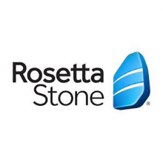
Expiration Date: 1/31/2026

T&C: See website for details. Powered by Access. Only one offer may be redeemed per visit. Offer may not be valid with other sales/promotions. Void if altered, transferred, purchased, or sold; use for these purposes is illegal and constitutes fraud. Other restrictions may apply. Offers are subject to change without notice. No cash value. © Access Development. All rights reserved. www.accessdevelopment.com



