FEATURED DEAL
Name: VIVA Finance

Offer Title: Personal loans based on employment, with instant $20 loan credit.

Redemption URL: https://dashboard.viva-finance.com/register?partner=AccessDevelopment&campaignId=d050fa30-58c1-4396-9932-c0178a81104e&redirect=https://lending.viva-finance.com/apply

Promo Code: Access20

Short Description: Fast and affordable personal loans based on employment, instead of just your credit score. Apply in minutes and receive funds as soon as the next business day. $20 loan credit automatically applied for Access members. Trusted by thousands of employees, with over 1,000 five-star reviews. Consolidate debt, catch up on bills, and more.

Logo: https://static.accessdevelopment.com/brand/d60e8313185a46c77129ab10aab7842058745498/VIVAFinance_434434086.png
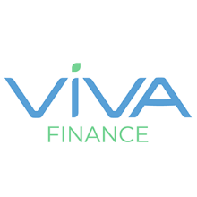
Expiration Date: 12/31/2025

T&C: $20 credit will be applied to customer’s loan as a principal payment. This will save the customer money on any interest that would have accrued on the additional $20 balance. Customer must either apply using the offer link or include the promo code in his or her application for the credit to be applied. Powered by Access. Only one offer may be redeemed per visit. Offer may not be valid with other sales/promotions. Void if altered, transferred, purchased, or sold; use for these purposes is illegal and constitutes fraud. Other restrictions may apply. Offers are subject to change without notice. No cash value. © Access Development. All rights reserved. www.accessdevelopment.com

