FEATURED DEAL
Name: Ghosts & Gravestones

Offer Title: Save on tickets at Ghost & Gravestones.

Redemption URL: Add this extension to the end of your savings program URL
/director?view=offer&offer_key=472262821

Offer Key: 472262821

Short Description: Prepare yourself for an evening of fun, scares, and ghost stories as you are guided through some of America’s most haunted cities. With its centuries of history and array of colorful characters, it is not surprising that the USA is home to many haunted places. Unseen spirits, lost souls and more linger among the streets, buildings and structures throughout the country. Ghosts & Gravestones are unique and customized to the city but with each sharing certain aspects such as the black trolleys, ghost hosts, and exclusive site visitation. Due to these unique features, the tour gained such national recognition that it has been featured on The Today Show, Sci-Fi Channel and The Travel Channel.

Logo: https://static.accessdevelopment.com/brand/37753157f6ef6805528666baf75732b4a7dde434/ChostsandGravestones_471465194.png

Expiration Date: 10/31/2026

T&C: Powered by Access. Valid only at the location listed. Only one offer may be redeemed per visit. Offer may not be valid with other sales/promotions. Void if altered, transferred, purchased or sold; use for these purposes is illegal and constitutes fraud. Other restrictions may apply. Offers are subject to change without notice. No cash value. © Access Development. All rights reserved. www.accessdevelopment.com

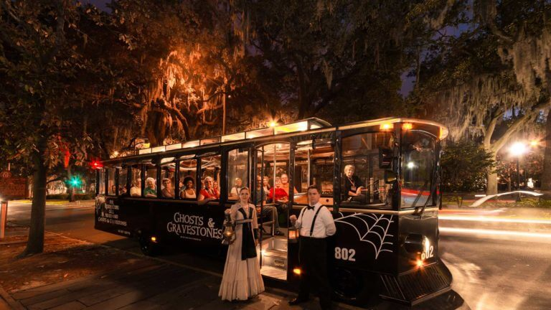

FEATURED DEAL
Name: FUN.com

Offer Title: 10% off your total purchase.

Redemption URL: https://www.fun.com/?CouponCode=funaccess10

Redeem Instructions: To redeem this offer, click link and discount will automatically be applied.

Offer Key: 457578815

Short Description: FUN is a big concept. Here at FUN.com, we want to help you in your search of products that deliver the kind of fun that YOU want. Whether it's a Star Wars plush, a t-shirt from the latest Disney hit, or you need a few gift ideas for your best friend's birthday. We're here to help! Over the years, our goals have always remained the same. No matter what you're looking for, we want FUN.com to be your GO-TO destination for exciting and unique gifts. And, as always, we provide awesome customer service unmatched in the industry, with quick and secure shipping, too. We will help you discover the best birthday, holiday, or anytime gift in the world! Now, if you're ready, let's have some FUN.

Logo: https://static.accessdevelopment.com/brand/402cb39f2a1c325e63f50a82563d2238945fe616/FUNcom_387551846_300x300.png

Expiration Date: 10/31/2026

T&C: Discount applied at checkout. Not valid with other offers or promotions. Other restrictions may apply. Powered by Access. Only one offer may be redeemed per visit. Void if altered, transferred, purchased or sold; use for these purposes is illegal and constitutes fraud. Other restrictions may apply. Offers are subject to change without notice. No cash value. © Access Development. All rights reserved. www.accessdevelopment.com



FEATURED DEAL
Name: Zombie Scavengers

Offer Title: 60% off entire purchase of up to 6 people.

Redemption URL: https://www.zombiescavengers.com

Promo Code: ACCESS60

Redeem Instructions: To redeem this offer, click link and enter promo code at checkout.

Offer Key: 283577574

Short Description: CAN YOU SURVIVE THE ZOMBIE APOCALYPSE? Zombie Scavengers leads you into the city to collect supplies to survive during this interactive scavenger hunt game. With the whole world in chaos and zombies outnumbering the living 10 to 1, small colonies of the living are doing all they can to survive. Using your smartphone, your team will be tasked with scavenging the city for food, supplies, weapons, and shelter. The more things you find, the more points you get and the more likely you are to survive. Along the way, you will be asked to do a challenge or answer a trivia question in order to be rewarded virtual weapons to ward off the zombies. The area is crawling with relentless zombies, and rival colonies are moving in. If you get too relaxed, rival colonies will take what you worked hard to find. The goal is to find all of the items in hopes that you will survive the zombie apocalypse while creating team building memories. Zombie Scavengers makes the perfect outing for birthday parties, team building, family fun, or even date night. You can have up to 10 people per team!

Logo:
https://static.accessdevelopment.com/brand/fc6036b614718b2400d2fb62d2a004a59ec6c1ea/original.png

Expiration Date: 10/31/2026

T&C: *Cannot be combined with other offers such as other coupon codes, Groupon vouchers, Living Social vouchers, or other vouchers. *Only valid on crazydash.com, wackywalks.com, 3questchallenge.com, operationcityquest.com, or zombiescavengers.com. *Not valid on Group packages. Powered by Access. Valid only at the location listed. Only one offer may be redeemed per visit. Offer may not be valid with other sales/promotions. Void if altered, transferred, purchased or sold; use for these purposes is illegal and constitutes fraud. Other restrictions may apply. Offers are subject to change without notice. No cash value. © Access Development. All rights reserved. www.accessdevelopment.com



FEATURED DEAL
Name: Lillian Vernon

Offer Title: 20% off Halloween Treat Bags

Redemption URL: https://fmtc.co/48598056/d99f47ec361410ac5ecb5c798fb641d1?sid=ADD_CVT

Promo Code: AFLITD20

Redeem Instructions: To redeem this offer, click link and enter promotion code at checkout.

Offer Key: 491297219

Short Description: Lillian Vernon Corporation is a leading 54-year-old national catalog and online retailer that markets gift, household, children's and fashion accessory products. The company specializes in personalization, organization and celebration. Lillian Vernon is well known for offering unique merchandise and good values.

Logo: https://static.accessdevelopment.com/brand/6ab332ecb25dd020f2585811a07b7eb1d770ebad/lillianVernon-logo-wht-bg-300x300.png

Expiration Date: 10/31/2026

T&C: Powered by Access. Valid only at the location listed. Only one offer may be redeemed per visit. Offer may not be valid with other sales/promotions. Void if altered, transferred, purchased or sold; use for these purposes is illegal and constitutes fraud. Other restrictions may apply. Offers are subject to change without notice. No cash value. © Access Development. All rights reserved. www.accessdevelopment.com

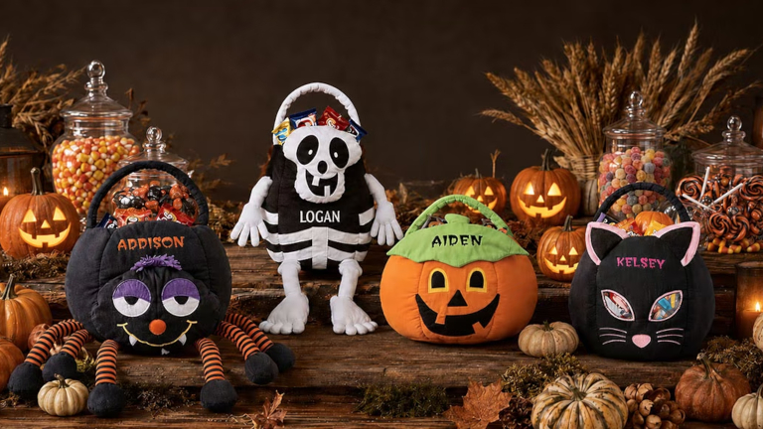

FEATURED DEAL
Name: Great Big Game Show

Offer Title: Save up to 30% on a Ticket Bundle!

Redemption URL: https://go.launchingdeals.com/TMPVMBM

Redeem Instructions: To redeem this offer, click link and discount will automatically be applied.

Offer Key: 483677276

Short Description: Two teams go head-to-head in a series of classic game show mini-games, on an immersive studio set, with a live host! It’s like all game shows you love, but this time, you’re the contestant. Play through rounds of strategy, chance, and knowledge, surrounded by spotlights, buzzers, a giant spinning wheel, and a confetti-filled celebration at the end!
Great Big Game Show Nashville is located inside Opry Mills Mall, surrounded by plenty of dining and shopping options. Celebrate your win with a victory meal at The Cheesecake Factory, Chuy’s, or Rainforest Café! Don't forget to swing by Molly's Cupcakes for a sweet treat after your game!

Logo: https://static.accessdevelopment.com/brand/7935f3a79821ab988562e756b386e4e7fdb8430a/GreatBigGameShow_Logo_300x300_03032026.png

Expiration Date: 10/31/2026

T&C: Powered by Access. Valid only at the location listed. Only one offer may be redeemed per visit. Offer may not be valid with other sales/promotions. Void if altered, transferred, purchased, or sold; use for these purposes is illegal and constitutes fraud. Other restrictions may apply. Offers are subject to change without notice. No cash value. © Access Development. All rights reserved. www.accessdevelopment.com



FEATURED DEAL
Name: Disney Store

Offer Title: Fall Sale: Up to 40% off Fall Favorites

Redemption URL: https://fmtc.co/48605716/d99f47ec361410ac5ecb5c798fb641d1?sid=ADD_CVT

Redeem Instructions: To redeem this offer, click link.

Offer Key: 491575998

Short Description: Disney Store is The Walt Disney Company's premier retailer, providing a distinctive Disney retail experience that encompasses all the best Disney branded apparel, toys and electronics, stationery, and home décor. Disney Store merchandise is inspired by classic Disney characters and key franchises, Walt Disney Studios and Disney-Pixar's blockbuster films, and hit Disney Channel programs. We are a unique destination for finding all the best Disney products for the entire family, with a redesigned site offering an exceptional Guest experience. Collectibles and other Disney merchandise previously only available at Disney Parks and Resorts are now available exclusively online at Disney Store.

Logo: https://static.accessdevelopment.com/brand/67e23d708846bbe4bae589f64d26fc93674e518d/DisneyStore_370528763_02292024.png

Expiration Date: 10/31/2026

T&C: Powered by Access. Valid only at the location listed. Only one offer may be redeemed per visit. Offer may not be valid with other sales/promotions. Void if altered, transferred, purchased or sold; use for these purposes is illegal and constitutes fraud. Other restrictions may apply. Offers are subject to change without notice. No cash value. © Access Development. All rights reserved. www.accessdevelopment.com

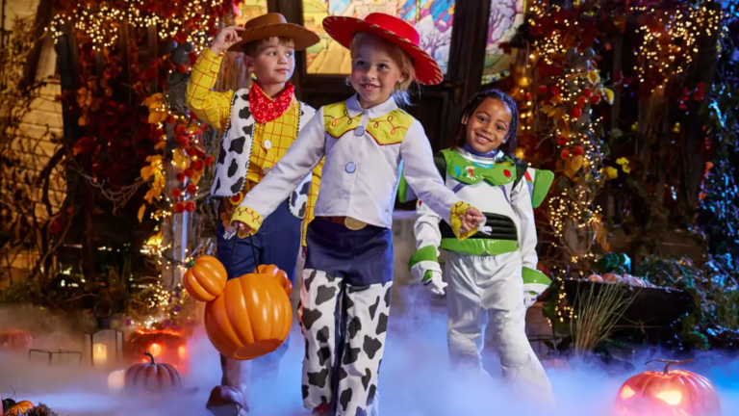

FEATURED DEAL
Name: Peets.com

Offer Title: 30% Off New Coffee Subscriptions

Redemption URL: https://fmtc.co/48315844/d99f47ec361410ac5ecb5c798fb641d1?sid=ADD_CVT

Promo Code: NEWSUB30

Redeem Instructions: To redeem this offer, click link and enter promotion code at checkout.

Offer Key: 477639462

Short Description: Since 1966, Peet's Coffee has offered superior coffees and teas by sourcing the best quality coffee beans and tea leaves in the world and adhering to strict high-quality and taste standards.

Logo: https://static.accessdevelopment.com/brand/2527dbf0392bce3dcc85c37a130e4ab41b93198b/PeetsCoffee_Logo_300x300.png

Expiration Date: 10/31/2026

T&C: Powered by Access. Valid only at the location listed. Only one offer may be redeemed per visit. Offer may not be valid with other sales/promotions. Void if altered, transferred, purchased or sold; use for these purposes is illegal and constitutes fraud. Other restrictions may apply. Offers are subject to change without notice. No cash value. © Access Development. All rights reserved. www.accessdevelopment.com

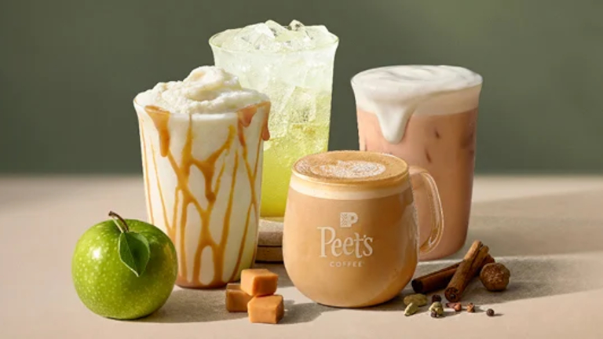

FEATURED DEAL
Name: Cinemark

Offer Title: Up to 20% off Cinemark e-tickets.

Redemption URL: Add this extension to the end of your savings program URL
/director?view=offer&offer_key=460068466

Offer Key: 460068466

Short Description: At Cinemark, we believe nothing compares to seeing movies the way they were truly intended - BIG. Every visit to our theatre is a larger-than-life experience, delivered to you with the latest in sight, sound and seating technology that puts you in the middle of all the action. Feel the vibrance of every scene. Hear every sound effect with breathtaking clarity. Immerse yourself in a world that's unforgettably cinematic.

Logo: https://static.accessdevelopment.com/brand/2341feca17dc3785c7dda0f383680f35f877072f/Cinemark_18938298_05192023.png

Expiration Date: 10/31/2026

T&C:
TICKETS ARE NONREFUNDABLE.
Recipient's e-mail address MUST be supplied in e-mail field on Shipping & Payment page. Each e-ticket is valid for one box office admission. Additional premiums may be applied for specially priced films and/or events which are priced higher than normal box office ticket pricing. Must be presented at box office. This ticket is non-refundable.
Not valid for special attractions, road show engagements or motion pictures where prohibited by contractual obligations. Check newspaper, box office or www.cinemark.com for local showtimes. Valid for one box office admission. May be redeemed at any Cinemark branded Theatre nationwide. Cinemark brands include Cinemark, Century Theatres, CineArts, Tinseltown and Rave Cinemas. Tickets are nonrefundable and cannot be exchanged for cash. Offer may not be valid with other sales/promotions. Void if altered, transferred, purchased or sold; use for these purposes is illegal and constitutes fraud. Other restrictions may apply. Offers are subject to change without notice. No cash value. © Access Development. All rights reserved. www.accessdevelopment.com



FEATURED DEAL
Name: Goldbelly

Offer Title:
Get $20 off your first order of $100 or more.
Experience some of the best foods from the best restaurants: fried chicken from The Red Chickz, Fish from Pike's Market, Junior's NY Cheesecake, Liebman's Deli or St. Elmo's famous Shrimp Cocktail.
We're not just another food delivery service - we bring you amazing food from many small businesses!

Redemption URL: https://goldbelly.pxf.io/c/24547/1976650/13451?subId1=ADD_CVT

Promo Code: BELLY20

Redeem Instructions: To redeem this offer, click link and enter promotion code at checkout.

Offer Key: 452444445

Short Description:
We believe that food brings people together, so we've created a place that connects people with their greatest food memories, experiences and desires. We've built a platform that empowers small shops, chefs & restaurants and inspires their passion.
Our mission is to bring you comfort through food.
Whatever you dream of. Wherever you are.

Logo: https://static.accessdevelopment.com/brand/66fa3ad83c99b4fba0c07c710cdb44d7b1ac58e7/goldbelly-logo.png

Expiration Date: 10/31/2026

T&C: First time orders only. Powered by Access. Valid only at the location listed. Only one offer may be redeemed per visit. Offer may not be valid with other sales/promotions. Void if altered, transferred, purchased or sold; use for these purposes is illegal and constitutes fraud. Other restrictions may apply. Offers are subject to change without notice. No cash value. © Access Development. All rights reserved. www.accessdevelopment.com

