FEATURED DEAL
Name: Invisible Fence®

Offer Title: $250 off a professionally installed Invisible Fence® Brand system.

Online Redemption URL: https://www.invisiblefence.com/pet-solutions?referral_code=AP250&promo=partners_ACCESSMEMBER&utm_source=partners&utm_medium=referral&utm_campaign=ACCESSMEMBER

Promo Code: AP250

Offer Key: 466338373

Short Description: Invisible Fence® Brand is the pet fence your neighbors love! Our expert training and innovative technology ensure that pets are safe, happy and free to explore their surroundings across the U.S. and Canada. With a commitment to quality and customer satisfaction, we offer a range of customizable solutions to fit the unique needs of the pets, homes, and lifestyles of your neighbors. Whether welcoming a new pet, settling into a new home, dealing with the distress of a lost pet, or simply wanting to give pets the freedom to roam safely, we can help! With over 50 years of experience, our solutions are backed by patented technology to provide your pet with the freedom they deserve, while keeping them safe at home—both indoors and out. From indoor and outdoor containment systems to behavioral training, Invisible Fence® Brand provides peace of mind for pet owners everywhere. Trust the brand that has protected over three million pets and counting.

Logo: https://static.accessdevelopment.com/brand/d5c6807fd0a59ebafe9061f70df314e71757acdd/InvisibleFenceBrand_Logo1_300x300.png

Expiration Date: 04/30/2026

T&C: (Participating dealers only. Cannot be combined with other offers or discounts. $1500 minimum purchase. Service and battery plans are purchased separately and would be an annual cost subsequent of this discount.) An exclusive offer only available to Access Development Members. Use code AP250 to claim your special offer. Powered by Access. Only one offer may be redeemed per visit. Offer may not be valid with other sales/promotions. Void if altered, transferred, purchased, or sold; use for these purposes is illegal and constitutes fraud. Other restrictions may apply. Offers are subject to change without notice. No cash value. © Access Development. All rights reserved. www.accessdevelopment.com

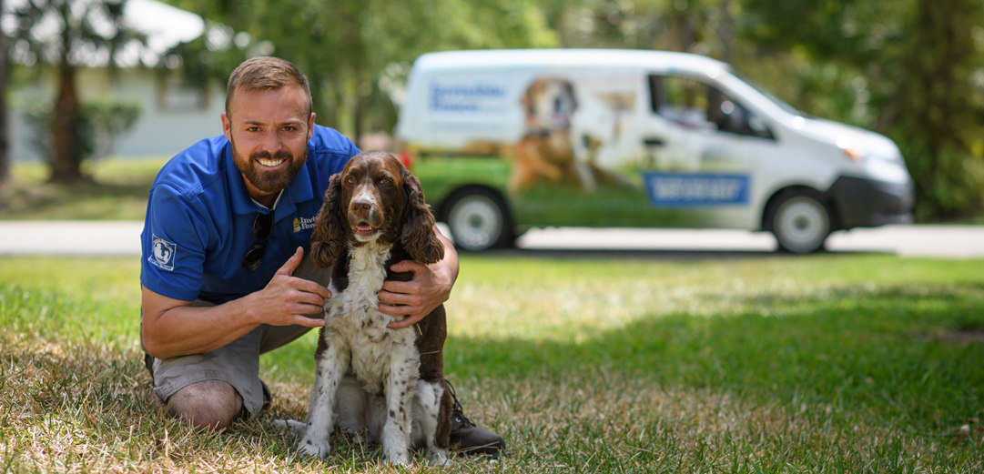

FEATURED DEAL
Name: Renewal by Andersen

Offer Title: Buy one, get one 40% off + $200 off your order.

Online Redemption URL: https://sendwiz1.com/?E=PxHGRl8skqlIKaVX2gBcHs9bX7m7FYfRDbfaF54T%2fx8%3d&s1=

Offer Key: 471058800

Short Description: Renewal by Andersen is dedicated to bringing new life to your home with windows and doors that welcome the light and frame a more beautiful world. Andersen is the window and door brand homeowners trust the most. Renewal by Andersen is the full-service replacement window division of Andersen. 2020 Andersen Brand Survey of U.S. Homeowners.

Logo: https://static.accessdevelopment.com/brand/5425915782d2c3d6bc50b6d5eb7d74675a9a1990/RenewalbyAndersen_Logo_300x300.png

Expiration Date: 04/30/2026

T&C: Powered by Access. Valid only at the location listed. Only one offer may be redeemed per visit. Offer may not be valid with other sales/promotions. Void if altered, transferred, purchased or sold; use for these purposes is illegal and constitutes fraud. Other restrictions may apply. Offers are subject to change without notice. No cash value. © Access Development. All rights reserved. www.accessdevelopment.com



FEATURED DEAL
Name: ADT

Offer Title: $850 in ADT-monitored home security equipment and a Google Nest Doorbell at No Cost. *

Online Redemption URL: https://go.launchingdeals.com/ZBXRW2H

Other Redemption Types: To redeem this offer call 844-303-4099 and mention that you saw this promotion.

Offer Key: 443003975

Short Description: Now’s your chance to pair ADT’s industry-leading Smart Security Monitoring with Google’s Smart Video Doorbell. ADT home security systems are backed by more than 146 years of experience. As the leader in home security, ADT can help you customize a home security system to meet your safety needs. From video surveillance to home automation, door sensors to carbon monoxide detectors… you´ll be safe with ADT.

Logo: https://static.accessdevelopment.com/brand/c5d00c87e86a7e8cf2fda62a89ac5efa141873a2/ADT_388008039_Logo_300X300.png

Expiration Date: 04/30/2026

T&C: ADT requires a 36-month contract to receive the Google Nest Doorbell bonus. See offer page for full details. Powered by Access. Only one offer may be redeemed per visit. Offer may not be valid with other sales/promotions. Void if altered, transferred, purchased, or sold; use for these purposes is illegal and constitutes fraud. Other restrictions may apply. Offers are subject to change without notice. No cash value. © Access Development. All rights reserved. www.accessdevelopment.com



FEATURED DEAL
Name: Big 5 Sporting Goods

Offer Title: $10 off purchase of $50 or more.

Online Redemption URL (add this to the end of your savings program URL): /director?view=offer&offer_key=482552547

Redemption Instructions: Use Redemption Link from your savings program to show coupon at time of purchase instore

Offer Key: 482552547

Short Description: Big 5 Sporting Goods is one of America's top retailers of name brand sporting goods and accessories. We provide a full-line product offering in a traditional sporting goods store format that averages approximately 11,000 square feet. Our product mix includes athletic shoes, apparel and accessories, as well as a broad selection of outdoor and athletic equipment for team sports, fitness, camping, hunting, fishing, tennis, golf, snowboarding and in-line skating.

Logo: https://static.accessdevelopment.com/brand/d3e1f705a91391c9c0252a6635d7b4d922de9a19/Big5_logo_300x300.png

Expiration Date: 04/30/2026

T&C: See www.big5.com/exclusions for terms and exclusions, including, but not limited to the following exclusions: One-Day Deals, 3-Day Deals, Weekly Ad Coupons, clearance items, gift cards, bulk orders, tickets/licenses, firearms, ammo, treadmills, golf and tennis balls, 2026 World Cup soccer balls, Team and Pokémon trading cards, LEGO, Columbia Apparel and certain other brands. Limit one coupon per customer. Not valid with other coupons or past purchases. Not redeemable for cash or cash equivalent. Discounts on multi-item purchases apportioned to items on a pro rata basis. EXPIRES 06/30/2026. Powered by Access. Valid only at the location listed. Only one offer may be redeemed per visit. Offer may not be valid with other sales/promotions. Void if altered, transferred, purchased or sold; use for these purposes is illegal and constitutes fraud. Other restrictions may apply. Offers are subject to change without notice. No cash value. © Access Development. All rights reserved. www.accessdevelopment.com



FEATURED DEAL
Name: Upside

Offer Title: Additional $5 bonus on your first offer (minimum spend $10)

Online Redemption URL: https://upside.sjv.io/c/24547/3373681/39811?param1=accesscash?sharedid=ADD_CVT

Promo Code: accesscash

Redeem Instructions: Click the link and scan the QR code on your phone to download the Upside app. Make sure you enter the code during the sign-up process in the app.

Offer Key: 478048387

Short Description: Upside is a free app that lets you earn cash back on essential purchases like gas, groceries, and dining. You can earn cash back at over 100k locations nationwide, including nearby gas stations, grocery stores, and restaurants. You earn cash back on the things you need, on top of your existing credit and debit rewards. Upside offers personalized offers for you—not confusing points, miles, or rebates. You can cash out directly to your bank account, or dozens of gift cards, with no minimums. With Upside, you can earn an average 8% cash back for dining and grocery purchases. Frequent Upside users earn about $290 per year.

Logo: https://static.accessdevelopment.com/brand/319d0db6da3018c69ef213c582100af312da2c44/Upside_Logo_300x300_10202025.png

Expiration Date: 04/30/2026

T&C: Valid for new customers only. Powered by Access. Only one offer may be redeemed per visit. Offer may not be valid with other sales/promotions. Void if altered, transferred, purchased, or sold; use for these purposes is illegal and constitutes fraud. Other restrictions may apply. Offers are subject to change without notice. No cash value. © Access Development. All rights reserved. www.accessdevelopment.com



FEATURED DEAL
Name: Empire Today

Offer Title: $350 off Empire Today’s Services

Online Redemption URL: https://empiretoday.sjv.io/BnEa01?subId1=ADD_CVT

Promo Code: ACCESS350

Redeem Instructions: To redeem this offer, click the link and schedule your free in-home estimate. During this process you will be asked to provide your contact information along with the promotion code on the last step. A flooring specialist will then come to your home with samples that you can choose from, will measure your rooms, and give you an estimate with your discounted rate.

Offer Key: 460478271

Short Description: Empire Today® is a full-service flooring provider operating in more than seventy markets across the country. Known for its iconic jingle in-home shopping experience and quick professional flooring installation services Empire® has been a leader in the industry for more than 65 years.

Logo: https://static.accessdevelopment.com/brand/0066a32bab2b1f1e91be1fc1ee4b6409d49ca92b/EmpireToday_435082548.png

Expiration Date: 04/30/2026

T&C: Discount applied to contract total of $3,500 or more before applicable taxes. Appointment must be scheduled by calling the number provided or scheduled online using the above link to be valid. Cannot be applied to deposit. May not be applied to Sales or combined with other coupons, discounts or savings. Not valid on prior purchases. Residential only. Limit one offer per household. Not available in all areas. Valid through 12/31/2026. Subject to change. Powered by Access. Only one offer may be redeemed per visit. Offer may not be valid with other sales/promotions. Void if altered, transferred, purchased, or sold; use for these purposes is illegal and constitutes fraud. Other restrictions may apply. Offers are subject to change without notice. No cash value. © Access Development. All rights reserved. www.accessdevelopment.com

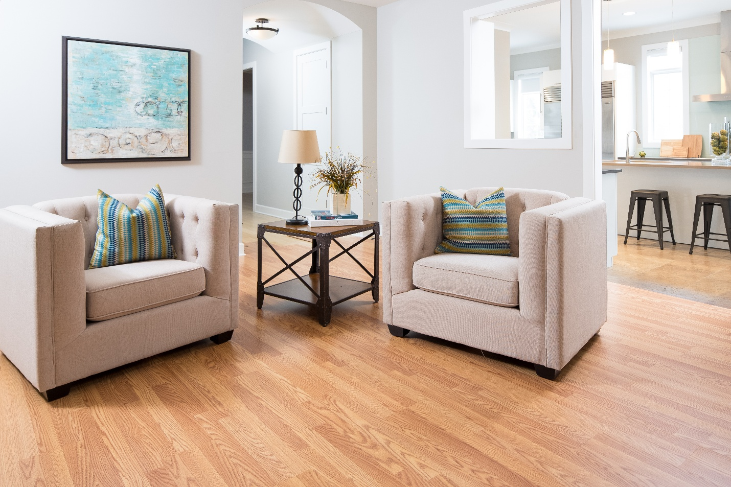

FEATURED DEAL
Name: Sherwin-Williams

Offer Title: $10 off purchase of $50 or more.

Redemption URL (add this to the end of your savings program URL): /director?view=offer&offer_key=482845607

Redemption Instructions: Use Redemption Link from your savings program to show coupon at time of purchase instore

Offer Key: 482845607

Short Description: Sherwin-Williams Paint Stores have exceptional quality paints, paint supplies, wallpaper, wood stains and sealers to bring your ideas to life. Painting Questions? Ask Sherwin-Williams

Logo: https://static.accessdevelopment.com/brand/8cab167bc2512b7964231364031950ae3de43964/SherwinWilliamsLogo300x300.png

Expiration Date: 04/30/2026

T&C: Valid on retail sales of retail products only. Minimum purchase of $50 in a single transaction, before sales tax and after all discounts have been applied. Savings is applied to qualifying items purchased on a prorated basis. Multiple dollars-off coupons will not be honored. Must surrender coupon at time of redemption. Cash value: 1/100 of 1¢. Offer excludes previous purchases, and purchases of gift cards. Other exclusions may apply, see store for details. Valid at US/Caribbean/Puerto Rico Sherwin-Williams retail paint stores only. We reserve the right to accept, refuse, or limit the use of any coupon. Offer valid through 12/31/26. Powered by Access. Valid only at the location listed. Only one offer may be redeemed per visit. Offer may not be valid with other sales/promotions. Void if altered, transferred, purchased or sold; use for these purposes is illegal and constitutes fraud. Other restrictions may apply. Offers are subject to change without notice. No cash value. © Access Development. All rights reserved. www.accessdevelopment.com.

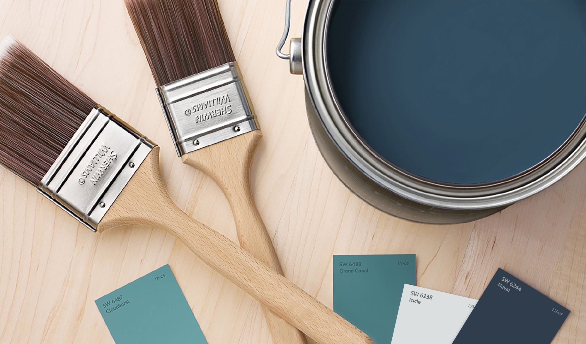

FEATURED DEAL
Name: LeafFilter

Offer Title: 75% Off Installation + $250 Off

Online Redemption URL: https://sendwiz1.com/?E=PxHGRl8skqn8H8PAGApzqKZHlmdYCNQKDbfaF54T%2fx8%3d&s1=

Offer Key: 471045755

Short Description: LeafFilter Gutter Protection is a permanent solution to clogged gutters and eliminates the dreaded task of gutter cleaning. Our micromesh filter installs on existing gutters in order to effectively prevent clogged gutters and the subsequent water damage they cause. As America's #1 rated gutter protection system, we provide the most effective debris-blocking system on the market, paired with an exceptional customer experience from beginning to end. Every purchase of LeafFilter is backed by an industry-leading warranty that is valid for the life of the home. Along with receiving positive gutter guard reviews, LeafFilter has been widely recognized as the leading gutter guard system by customers, media outlets, and review services.

Logo: https://static.accessdevelopment.com/brand/bcef50385b89198fe7d2e39c91d51a95ddfa8cda/original.png

Expiration Date: 04/30/2026

T&C: Powered by Access. Valid only at the location listed. Only one offer may be redeemed per visit. Offer may not be valid with other sales/promotions. Void if altered, transferred, purchased or sold; use for these purposes is illegal and constitutes fraud. Other restrictions may apply. Offers are subject to change without notice. No cash value. © Access Development. All rights reserved. www.accessdevelopment.com



FEATURED DEAL
Name: American Home Shield

Offer Title: $100 off all home warranty plans.

Online Redemption URL: https://american-home-shield.sjv.io/c/24547/2119214/12016?subId1=ADD_CVT

Promo Code: AD100

Offer Key: 456588177

Short Description: Founded in 1971, American Home Shield (AHS) is a leading home warranty provider offering three plans with various inclusions and higher-than-average coverage limits American Home Shield Corporation is an American home warranty company based in Memphis, Tennessee. American Home Shield has more than 50 years of experience in the home warranty industry.

Logo: https://static.accessdevelopment.com/brand/6c6b3e841dae57752cfb3f74e9ce91fef13ed2a5/AmericanHomeShield_456587988.png

Expiration Date: 04/30/2026

T&C: Not in conjunction with any other offer. AHS is not available in Hawaii or Alaska. Powered by Access. Valid only at the location listed. Only one offer may be redeemed per visit. Offer may not be valid with other sales/promotions. Void if altered, transferred, purchased or sold; use for these purposes is illegal and constitutes fraud. Other restrictions may apply. Offers are subject to change without notice. No cash value. © Access Development. All rights reserved. www.accessdevelopment.com



FEATURED DEAL
Name: Window Genie

Offer Title: $25 off any service of $200 or more

Redemption URL (add this to the end of your savings program URL): /director?view=offer&offer_key=443426729

Redeem Instructions:
To redeem this offer follow these steps:
Go to https://www.windowgenie.com/ or call 844-389-7846 and book your appointment. Make sure you mention the discount offer when booking your appointment.
Use Redemption Link from your savings program to show coupon at time of service
Offer Key: 443426729

Short Description: Window Genie® specializes in residential and commercial window cleaning, pressure washing, holiday lighting, gutter cleaning, and window tinting. With Window Genie locations across the country, we’re committed to providing professional home services near you throughout the year.

Logo: https://static.accessdevelopment.com/brand/6950016ca47fdf74e2506400f7fe28999c420235/WindowGenie_Logo_300x300_04112025.png

Expiration Date: 04/30/2026

T&C: No cash value. Terms and Limits Apply. Coupon must be presented at time of estimate. Not valid with any other offer. One offer per household. Powered by Access. Valid for first time customers only. Not applicable to customers already using a current recurring service agreement. All services are performed by independently owned and operated franchise locations/companies. Valid only at participating locations. Other restrictions may apply. Offers are subject to change without notice. © 2025 Neighborly Company and its affiliates. All rights reserved. Neighborly is a registered trademark of Neighborly Asset Co LLC. Time Limit for claims applies. For terms visit www.neighborly.com/terms-of-use. Powered by Access. Valid only at the location listed. Only one offer may be redeemed per visit. Offer may not be valid with other sales/promotions. Void if altered, transferred, purchased or sold; use for these purposes is illegal and constitutes fraud. Other restrictions may apply. Offers are subject to change without notice. No cash value. © Access Development. All rights reserved. www.accessdevelopment.com



