FEATURED DEAL
Name: Claire's

Offer Title: 20% off purchase of $35 or more.

Redemption URL: Put this URL extension at the end of your savings program URL /director?view=offer&offer_key=483322925

Redeem Instructions: Present coupon at time of purchase

Offer Key: 483322925

Short Description: Every girl's favorite place to get the latest trends in fashion accessories.

Logo: https://static.accessdevelopment.com/brand/1a3fd5103747979cec0da92cf7233989d6fefc8a/original.png

Expiration Date: 08/31/26

T&C: May not be combined with any other coupon, discount, sale or promotion; not valid on prior purchases. Not valid on piercing, other services or gift cards. Coupon offers may vary online. Not redeemable for cash or credit. Void if sold, duplicated or reproduced and cannot be replaced if lost, stolen or damaged. In the event of a return or exchange, the discount will be forfeited and may not be reused. Refer to in-store return policy for details. Associates of Claire’s Essentials LLC or its affiliates are not eligible. Percentage off discount will be off pre-tax purchase amount. Valid until 12/31/2026. Powered by Access. Valid only at the location listed. Only one offer may be redeemed per visit. Offer may not be valid with other sales/promotions. Void if altered, transferred, purchased or sold; use for these purposes is illegal and constitutes fraud. Other restrictions may apply. Offers are subject to change without notice. No cash value. © Access Development. All rights reserved. www.accessdevelopment.com



FEATURED DEAL
Name: Clarks

Offer Title: 20% Off Entire Purchase.

Redemption URL: Put this URL extension at the end of your savings program URL /director?view=offer&offer_key=447515964

Promo Code: ACCESS20

Redeem Instructions: Present coupon at time of purchase

Offer Key: 447515964

Short Description: Discover the latest shoe trends & footwear styles at Clarks. Explore our range of fashionable shoes, trendy sandals, casual trainers & iconic boots.

Logo: https://static.accessdevelopment.com/brand/2847c79d901dfacb6a697417b9ead4acf59d8149/Clarks_Logo_300X300_01082024.png

Expiration Date: 08/31/26

T&C: Valid at full price and outlet locations. Certain exclusions may apply. See store for details.
Powered by Access. Valid only at the location listed. Only one offer may be redeemed per visit. Offer may not be valid with other sales/promotions. Void if altered, transferred, purchased or sold; use for these purposes is illegal and constitutes fraud. Other restrictions may apply. Offers are subject to change without notice. No cash value. © Access Development. All rights reserved. www.accessdevelopment.com


FEATURED DEAL
Name: Auntie Anne's

Offer Title: Buy one pretzel, get one free.

Redemption URL: https://www.auntieannes.com/rewards

Promo Code: PRETZELQ3

Redeem Instructions: How to Redeem This Offer:
1. Open the Auntie Anne’s Rewards App. If you don't already have it download it on Google Play, or the Apple Store.
2. Enter coupon code ${redeem.online_link_promotionCode} on the home screen of the app to unlock the offer.
3. Redeem under the Rewards section of the app on an online or in-store order.

Offer Key: 476529985

Short Description: Twisting things up since 1988. Get hot and handmade pretzel snacks with refreshing drinks like our classic lemonade and more!
New Auntie Anne’s Rewards members enjoy a free pretzel after your first $1 spent, a free pretzel on your birthday when you spend $10+ annually, and other exclusive member offers.

Logo: https://static.accessdevelopment.com/brand/c1cfa88cbe73bbf1494c56775c57f86eae3b1105/AuntieAnnesLogo18938099_300X300_20240802.png

Expiration Date: 08/31/26

T&C: Buy one pretzel, get one free offer valid for 28 days from time promo code is added to your Auntie Anne's Reward account online or through app. Valid only for Original and Cinnamon Sugar Pretzel. Offer must be redeemed using a valid Auntie Anne’s Rewards account and can only be redeemed in store at participating locations; not available in Puerto Rico or U.S. Virgin Islands. Excludes Auntie Anne’s/SUBWAY® locations and most travel plazas and airport locations. Single use. Must apply Reward at checkout. Not valid with any other offer or reward or delivery. Other fees and taxes may apply for all orders; see checkout for details. Void where prohibited.
Free pretzel offer excludes taxes and fees. Offer valid 45 days after issue date. Limit one offer per person. Not valid with any other promotion or offer. Reward excludes regular size nuggets, pretzel buckets, and catering items. If multiple pretzels are purchased, the lower priced item will be discounted. No cash value. Non-transferable. Sale, resale, and/or internet distribution strictly prohibited. Valid only at participating U.S. Auntie Anne’s locations.
Visit https://www.auntieannes.com/legal for full Auntie Anne’s Rewards terms and conditions. TM/© 2026 Auntie Anne’s Franchisor SPV LLC. All rights reserved.
Powered by Access. Valid only at the location listed. Only one offer may be redeemed per visit. Offer may not be valid with other sales/promotions. Void if altered, transferred, purchased or sold; use for these purposes is illegal and constitutes fraud. Other restrictions may apply. Offers are subject to change without notice. No cash value. © Access Development. All rights reserved. www.accessdevelopment.com

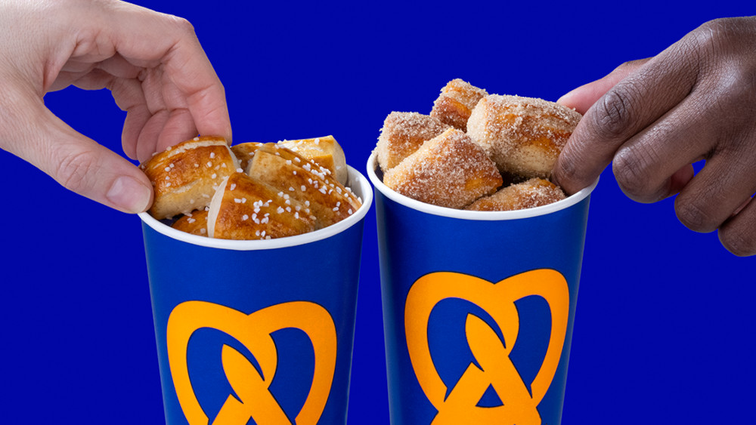

FEATURED DEAL
Name: Dell

Offer Title: Additional 5% off.

Redemption URL: https://www.anrdoezrs.net/click-7273667-17185822?sid=ADD_CVT

Redeem Instructions: To redeem this offer online, click here., then sign into or create Dell account. Savings will be shown at checkout by clicking "Show Savings".

Offer Key: 479971560

Short Description: For more than 26 years, Dell has empowered countries, communities, customers and people everywhere to use technology to realize their dreams. Customers trust us to deliver technology solutions that help them do and achieve more, whether they're at home, work, school or anywhere in their world.

Logo: https://static.accessdevelopment.com/brand/581d3d864bb1316493d5d190e60919ed01cd3375/Dell_18938383_300x300.png

Expiration Date: 08/31/2026

T&C: All are subject to approval acceptance by Dell. Offers subject to change, not combinable with all other offers. Taxes, shipping, handling and other fees apply. Valid for U.S. Dell Member Purchase Program/Dell University new purchases only. Dell reserves the right to cancel orders arising from pricing or other errors. Coupon Offer: Offers subject to change. Taxes, shipping, handling and other fees apply. Valid for new U.S. online purchases through the Dell MPP Electronics and Accessories site and for phone orders of electronics and accessories. Free shipping and handling offer available in Continental (except Alaska) U.S. only. Availability of electronics and accessories varies and quantities may be limited. Dell reserves the right to cancel orders arising from pricing or other errors. Not valid for resellers and/or online auctions. Purchase limit of 5 items per order, but coupon discount applies to only 1 item. Market Value is an estimate based on industry data such as published and as-sold prices for the same or comparable products in a survey of major online and/or offline retailers. Rewards are provided in the form of a promotional code. 10% back in rewards valid only on purchases using Dell Preferred Account and Dell Advantage Loyalty Program. 5% back in rewards valid on all other Dell Advantage purchases. Bose products only eligible for 5% rewards with Dell Advantage. Rewards arrive separately from purchase, typically in 10-20 days from ship date via email; expires in 90 days (except where prohibited by law). Terms and conditions apply. Dell.com/rewardterms. Second Business Day Shipping: Not available on televisions 40" or larger and 55" Dell branded monitors. *System Memory and Graphics: GB means 1 billion bytes and TB equals 1 trillion bytes; significant system memory may be used to support graphics, depending on system memory size and other factors. *Hard drives: GB means 1 billion bytes and TB means 1 trillion bytes; actual capacity varies with preloaded material and operating environment and will be less. Inspiron is a trademark of Dell, Inc.
Powered by Access. Offer may not be valid with other sales/promotions. Void if altered, transferred, purchased or sold; use for these purposes is illegal and constitutes fraud. Other restrictions may apply. Offers are subject to change without notice. © Access Development. All rights reserved. www.accessdevelopment.com



FEATURED DEAL
Name: Dick's Sporting Goods

Offer Title: Hydration Sale - Save on Stanley, Hydro Flask, Yeti & More

Redemption URL: https://fmtc.co/48456122/d99f47ec361410ac5ecb5c798fb641d1?sid=ADD_CVT

Redeem Instructions: Click link and offer will automatically be applied

Offer Key: 483739687

Short Description: Visit DICK'S Sporting Goods and Shop a Wide Selection of Sports Gear, Equipment, Apparel and Footwear!

Logo: https://static.accessdevelopment.com/brand/50608015184840c7e838312ad513cc05d9c9a885/DicksSportingGoods_logo_300x300.png

Expiration Date: 08/31/2026

T&C: Powered by Access. Valid only at the location listed. Only one offer may be redeemed per visit. Offer may not be valid with other sales/promotions. Void if altered, transferred, purchased or sold; use for these purposes is illegal and constitutes fraud. Other restrictions may apply. Offers are subject to change without notice. No cash value. © Access Development. All rights reserved. www.accessdevelopment.com



FEATURED DEAL
Name: Famous Footwear

Offer Title: Sign-up and Get $5 off $25+ Orders.

Redemption URL: https://fmtc.co/47349385/d99f47ec361410ac5ecb5c798fb641d1?sid=ADD_CVT

Redeem Instructions: Click link and offer will automatically be applied

Offer Key: 457200424

Short Description: At Famous Footwear we know shoes are more than just something you put on your feet. Wearing the right shoe helps you make the most of every day. That's why we have fantastic brand name shoes at great values for women, men and kids. With over 950 stores nationwide, we're committed to providing you with the brands you demand at prices you deserve. At Famous Footwear, you'll find the hottest brands including Nike, Puma, adidas, New Balance, ASICS, Steve Madden, DC Shoes, Skechers, Converse and so many more! See where our shoes can take you today. Make today Famous.

Logo: https://static.accessdevelopment.com/brand/9abad41f2a19ae236590f987d46e107ffbe485c8/original.png

Expiration Date: 08/31/26

T&C: Powered by Access. Valid only at the location listed. Only one offer may be redeemed per visit. Offer may not be valid with other sales/promotions. Void if altered, transferred, purchased or sold; use for these purposes is illegal and constitutes fraud. Other restrictions may apply. Offers are subject to change without notice. No cash value. © Access Development. All rights reserved. www.accessdevelopment.com

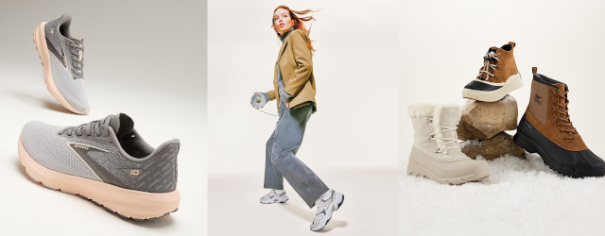

FEATURED DEAL
Name: HP Store

Offer Title: Up to 40% off performance tech.

Redemption URL: http://www.hpdirect.com/member/accessdevelopment

Redeem Instructions: Click here and create an account for the HP Employee Purchase Program to receive exclusive discounts and offers.

Offer Key: 283968729

Short Description: HP Inc is a multi-national technology company with HP.com online store providing a variety of hardware components as well as software and related services to consumers, small and medium-sized businesses and large enterprises.

Logo: https://static.accessdevelopment.com/brand/332b9592684d6d59c6143058db7c1e6781327fc6/HPStore_18938676_Logo.png

Expiration Date: 08/31/2026

T&C: Offer valid while supplies last and is subject to change or cancellation at any time. See product page for details. Prices shown may include applicable instant savings. Contract and volume customers not eligible. Not valid with any other promotions and valid in U.S. only. Savings achieved by combining EPP savings with instant savings.
Powered by Access. Valid only at the location listed. Only one offer may be redeemed per visit. Offer may not be valid with other sales/promotions. Void if altered, transferred, purchased or sold; use for these purposes is illegal and constitutes fraud. Other restrictions may apply. Offers are subject to change without notice. No cash value. © Access Development. All rights reserved. www.accessdevelopment.com



FEATURED DEAL
Name: Macys.com

Offer Title: Girls Coats Now: $49.99 and Under

Redemption URL: https://fmtc.co/48457537/d99f47ec361410ac5ecb5c798fb641d1?sid=ADD_CVT

Redeem Instructions: Click link and offer will automatically be applied

Offer Key: 483756713

Short Description: Macy's, established in 1858, is the Great American Department Store – an icon in the retail world. Macy's offers powerful assortments and the best brands, tailored to each and every customer with obvious value, engaging service and unforgettable moments. We offer men and women's clothing, shoes and accessories.

Logo: https://static.accessdevelopment.com/brand/34d3c71dbef17cc72eaf8d90eab897af0be6bae0/original.png

Expiration Date: 08/31/2026

T&C: Powered by Access. Valid only at the location listed. Only one offer may be redeemed per visit. Offer may not be valid with other sales/promotions. Void if altered, transferred, purchased or sold; use for these purposes is illegal and constitutes fraud. Other restrictions may apply. Offers are subject to change without notice. No cash value. © Access Development. All rights reserved. www.accessdevelopment.com



FEATURED DEAL
Name: Office Depot® and OfficeMax®

Offer Title: Buy 1 Get 1 50% off ALL BIC Pens, Pencils, Wite-Out and more with code BICBOGO

Redemption URL: https://fmtc.co/48518850/d99f47ec361410ac5ecb5c798fb641d1?sid=ADD_CVT

Promo Code: BICBOGO

Redeem Instructions: Enter promo code at checkout

Offer Key: 485437806

Short Description: Members can save on a variety of products including office and school supplies, ink and toner, electronics and furniture. At Office Depot® and OfficeMax®, we have the office supplies you need to manage your workload and your day, so you can be at the front line of business. We're here to help you succeed with top, trusted brands of office products, technology and office furniture that deliver the performance and quality that you deserve.

Logo: https://static.accessdevelopment.com/brand/bde3414985acb539c234c29d18d7d8d362b22281/OfficeDepotOfficeMax2_Logo_300X300.png

Expiration Date: 08/31/2026

T&C: Powered by Access. Valid only at the location listed. Only one offer may be redeemed per visit. Offer may not be valid with other sales/promotions. Void if altered, transferred, purchased or sold; use for these purposes is illegal and constitutes fraud. Other restrictions may apply. Offers are subject to change without notice. No cash value. © Access Development. All rights reserved. www.accessdevelopment.com



FEATURED DEAL
Name: Kumon

Offer Title: $30 Amazon gift card with new Kumon enrollment

Redemption URL: Put this URL extension at the end of your savings program URL /director?view=offer&offer_key= 485968334

Redeem Instructions: To redeem this offer you must be registered at a local Kumon center. To get started, choose a location near you and schedule your free assessment.
Once registered you will log in to the student's myKUMON Portal, select Access from the menu, and enter in the Perk Code you receive. A confirmation email will then be sent to you with additional instructions on how to redeem your Amazon gift card.

Offer Key: 485968334

Short Description: Kumon is an after-school learning program offering math and reading support for children. Families enroll at a local Kumon Center and use the myKUMON Portal for learning and communication.

Logo: https://static.accessdevelopment.com/brand/52a8ca38ad00f13650256d8fc12845e9d2c3306b/Kumon_Logo_300x300_07012026.png

Expiration Date: 08/31/2026

T&C: Limited to one gift card per student. Each unique discount code can only be redeemed once. Must enroll by September 30, 2026. While supplies last. Powered by Access. Valid only at the location listed. Only one offer may be redeemed per visit. Offer may not be valid with other sales/promotions. Void if altered, transferred, purchased, or sold; use for these purposes is illegal and constitutes fraud. Other restrictions may apply. Offers are subject to change without notice. No cash value. © Access Development. All rights reserved. www.accessdevelopment.com



