FEATURED DEAL
Name: Costco

Offer Title: $40 digital Costco Shop Card when you join as a new Executive Member and enroll in auto renewal.

Redemption URL: https://www.jdoqocy.com/click-7273667-15398217?sid=ADD_CVT

Promo Code: CJPROMO

Short Description: Looking for quality, value and convenience? Think Costco. vCostco is a membership club and committed to providing high-quality goods and services at an incredible value for its members. You'll find everything you need from school supplies and organic foods and snacks to laptops and electronics with the latest technology.
Shop confidently, online or in person, knowing that Costco is a company with a conscience and continues to adapt as we learn about our global impact with a commitment to sustainability. The ways that Costco can fit your lifestyle are endless. Find out what more than 100 million Costco members already know and join today.

Logo: https://static.accessdevelopment.com/brand/9f4c477b8809a6fe623a679b60243dd3972d340e/Costco_18938349_07062023.png
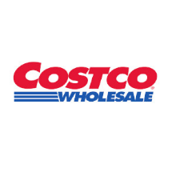
Expiration Date: 12/31/2025

T&C: Offer valid for US Members only. *To receive a Digital Costco Shop Card, you must provide a valid email address and set up auto renewal of your Costco membership on a Visa® card at the time of sign-up. If you elect not to provide a valid email address and sign up for auto renewal, a Digital Costco Shop Card will not be emailed.Valid only for nonmembers for their first year of membership. Not valid for renewal or upgrade of an existing membership. Valid only for new members and those whose previous memberships (Primary and Household) have been expired for at least 18 months or more. Limit one promotion/incentive per household. Promotion is non-transferable and may not be combined with any other promotion. Digital Costco Shop Card is not redeemable for cash, except as required by law. New members will receive their Digital Costco Shop Card by email within 2 weeks of sign-up. Costco is not liable for incentives not received due to entry of an invalid address during sign-up. Digital Costco Shop Cards are not accepted at Gas Stations, Car Wash, Food Court Kiosk or Self-Checkout. A Costco membership is $60 a year. An Executive Membership is an additional $60 upgrade fee a year. Each membership includes one free Household Card. May be subject to sales tax. Costco accepts all Visa cards, as well as cash, checks, debit/ATM cards, EBT, and Costco Shop Cards. Departments and product selection may vary. *Use the provided single-use promo code when entering your payment information. (Note: You will see a $0.01 deduction on your membership cost after the promo code is entered. This indicates that your promo code has been successfully processed so your incentive will be emailed.) New members will not receive the promotion if the provided code is not entered at checkout when purchasing the membership. The offers are not exclusive, but are the best value at the store right now. This offer contains affiliate links. Powered by Access. Offer may not be valid with other sales/promotions. Void if altered, transferred, purchased or sold; use for these purposes is illegal and constitutes fraud. Other restrictions may apply. Offers are subject to change without notice. No cash value. © Access Development. All rights reserved. www.accessdevelopment.com

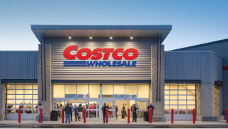

FEATURED DEAL
Name: Papa John’s

Offer Title: 20% off regular menu price online orders.

Redemption URL: https://www.papajohns.com/

Promo Code: 20OFFAD

Short Description: Papa John's really delivers, because we are focused on quality pizza. And it starts with our Better Ingredients, like our fresh, never frozen, original dough, all natural-sauce, 100% real meats and fresh-sliced veggies. And, we think you'll taste the difference, because "Nobody does what Papa John's does." Order online today and use your pizza discount! We always have pizza specials and deals.

Logo: https://static.accessdevelopment.com/brand/eea60774d245f4dabad6647a738e3685f1ee7da5/PJ_Logo_300X300.png
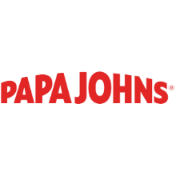
Expiration Date: 12/31/2025

T&C: Offer good online only for regular menu price items for a limited time at participating U.S. Papa Johns restaurants. Not valid with any other coupons or discounts. Limited delivery area. Delivery fee may apply and is not subject to discount offer. Customer responsible for all applicable taxes. ©2024 Papa John's International, Inc. All Rights Reserved. Powered by Access. Offer may not be valid with other sales/promotions. Void if altered, transferred, purchased or sold; use for these purposes is illegal and constitutes fraud. Other restrictions may apply. Offers are subject to change without notice. © Access Development. All rights reserved. www.accessdevelopment.com

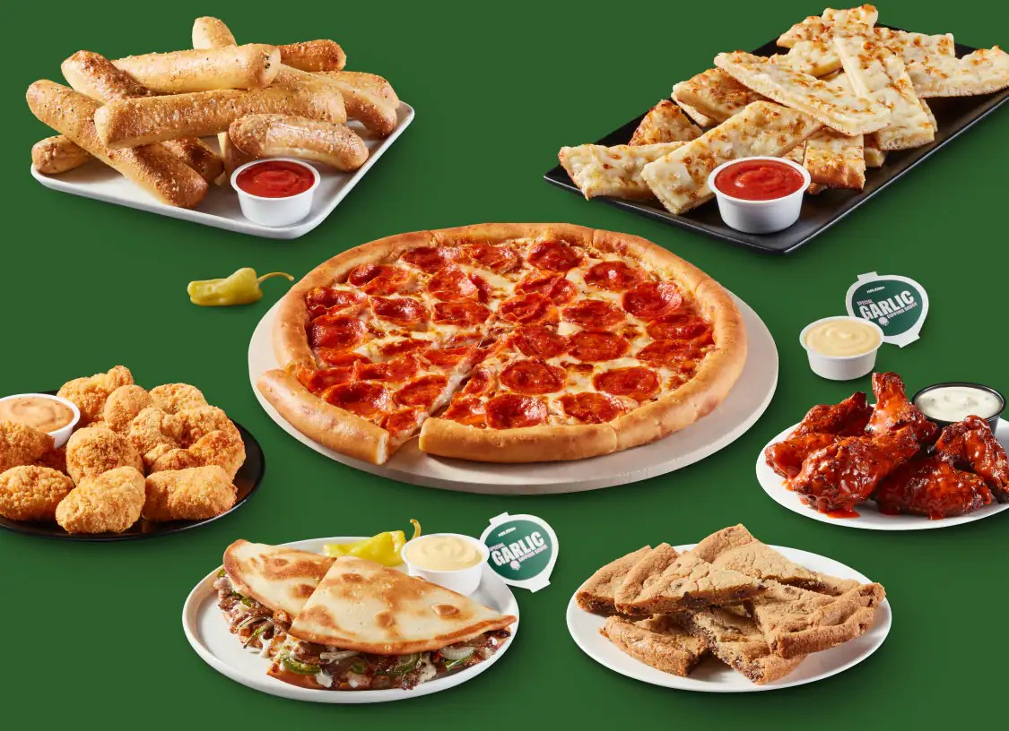

FEATURED DEAL
Name: Electrolux

Offer Title: Up to 50% off + Free Delivery.

Redemption URL: https://www.electroluxfamilystore.com/en/login/register/affiliate/Access%20Development?utm_source=Access+Development&utm_medium=referral&utm_campaign=Access+Development

Short Description: Electrolux is determined to eliminate the barriers that prevent you from making more sustainable choices for your home appliances. Through exclusive access to The Family Store, Electrolux is offering up to 50% off appliances plus free delivery on all orders.

Logo: https://static.accessdevelopment.com/brand/62d4ffc2fc57e7b48257c687d2c24051843ae3c1/Electrolux_Logo_300x300.png

Expiration Date: 12/31/2025

T&C: Product availability may vary by region. Home delivery, installation, and haul away options are only available in select US markets. Pricing information from The Family Store website is confidential and intended for users of this program only. Offer subject to change. Powered by Access. Offer may not be valid with other sales/promotions. Void if altered, transferred, purchased, or sold; use for these purposes is illegal and constitutes fraud. Other restrictions may apply. Offers are subject to change without notice. No cash value. © Access Development. All rights reserved. www.accessdevelopment.com



FEATURED DEAL
Name: VIVA Finance

Offer Title: Personal loans based on employment, with instant $20 loan credit.

Redemption URL: https://dashboard.viva-finance.com/register?partner=AccessDevelopment&campaignId=d050fa30-58c1-4396-9932-c0178a81104e&redirect=https://lending.viva-finance.com/apply

Promo Code: Access20

Short Description: Fast and affordable personal loans based on employment, instead of just your credit score. Apply in minutes and receive funds as soon as the next business day. $20 loan credit automatically applied for Access members. Trusted by thousands of employees, with over 1,000 five-star reviews. Consolidate debt, catch up on bills, and more.

Logo: https://static.accessdevelopment.com/brand/d60e8313185a46c77129ab10aab7842058745498/VIVAFinance_434434086.png
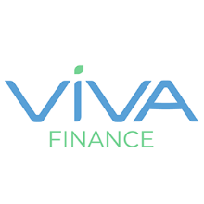
Expiration Date: 12/31/2025

T&C: $20 credit will be applied to customer’s loan as a principal payment. This will save the customer money on any interest that would have accrued on the additional $20 balance. Customer must either apply using the offer link or include the promo code in his or her application for the credit to be applied. Powered by Access. Only one offer may be redeemed per visit. Offer may not be valid with other sales/promotions. Void if altered, transferred, purchased, or sold; use for these purposes is illegal and constitutes fraud. Other restrictions may apply. Offers are subject to change without notice. No cash value. © Access Development. All rights reserved. www.accessdevelopment.com

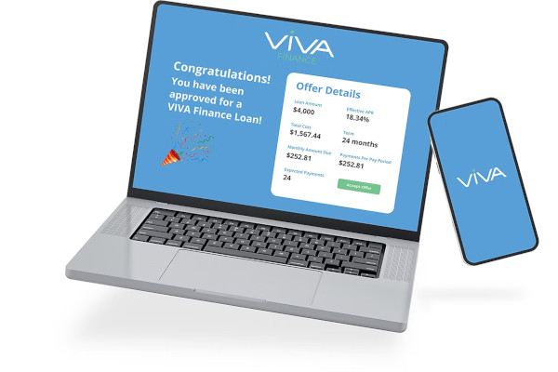

FEATURED DEAL
Name: Hard Rock Cafe

Offer Title: 15% Off Catering Orders.

Redemption URL: https://cafe.hardrock.com/catering.aspx

Promo Code: AccessApp

Short Description: Take center stage while being immersed in a world of music, iconic memorabilia, and of course – delicious food. Receive the Rock Star treatment while enjoying a mouth-watering menu that is home to our famous Legendary® Burger, luscious libations, and more.

Logo: https://static.accessdevelopment.com/brand/f93574ab5ddabd68e4259d7b45e1b6e6a8c62181/HardRockCafe_Logo_300X300.png
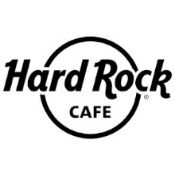
Expiration Date: 12/31/2025

T&C: Offers have no cash value, except where required by law, and cannot be combined with any other offers or discounts. Hard Rock Cafe reserves the right to cancel or change offers without notice. Other restrictions may apply. Powered by Access. Only one offer may be redeemed per visit. Offer may not be valid with other sales/promotions. Void if altered, transferred, purchased, or sold; use for these purposes is illegal and constitutes fraud. Other restrictions may apply. Offers are subject to change without notice. No cash value. © Access Development. All rights reserved. www.accessdevelopment.com
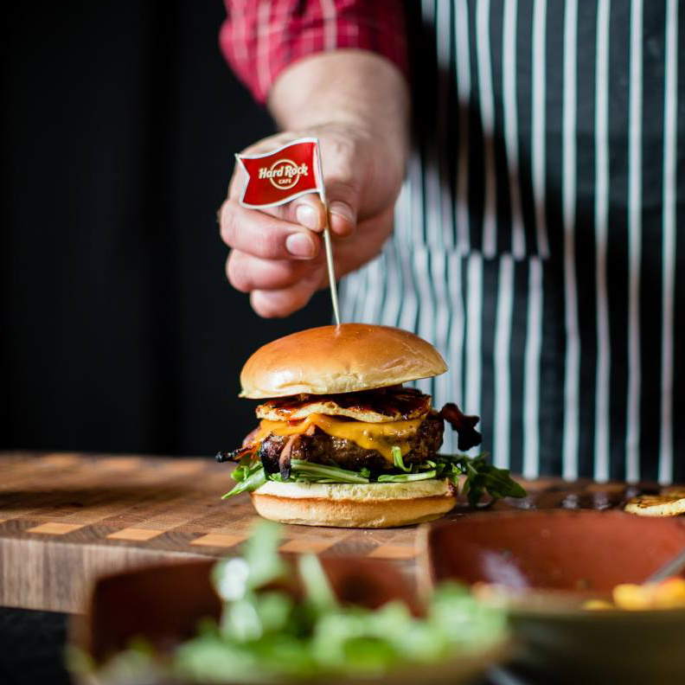

FEATURED DEAL
Name: T-Mobile Wireless from Previ

Offer Title: Get an iPhone 17 Pro for $0 with 24 months of T-Mobile service.

Redemption URL: https://getstarted.previ.com/?accessCode=accu3kb&affinity=tmo&utm_medium=exclusive_email&utm_source=perks_page&utm_campaign=q4_promo

Short Description: Previ is an exclusive membership offering superior pricing on premium services such including T-Mobile and AT&T Unlimited Nationwide Wireless Plans.

Logo: https://static.accessdevelopment.com/brand/938274e54c112c409a6b38191e91e98c1a9bf172/TMobile_Previ_Logo_300x300.png
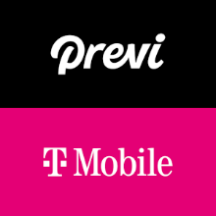
Expiration Date: 12/31/2025

T&C: iPhone 17 Pro 256 GB MSRP $1,099. $0 price requires eligible trade-in of iPhone 13 Pro or later, new port-in, Previ Device Plus T-Mobile program ($15/mo Unlimited + $37/mo program + taxes/fees) prepaid for 24 months via Affirm. $99 annual Previ membership is paid separately at signup and renews each year. Taxes and fees on full device MSRP and service vary by location and are financed in monthly installments. Trade-in value paid to customer as cash or cash equivalents; does not reduce Affirm-financed balance unless applied by customer. Subject to approval through Affirm. Savings based on Experience Beyond plan with a 3-line bill, calculated using one eligible trade-in device and two bring-your-own-device (BYOD) lines. Powered by Access. Valid only at the location listed. Only one offer may be redeemed per visit. Offer may not be valid with other sales/promotions. Void if altered, transferred, purchased, or sold; use for these purposes is illegal and constitutes fraud. Other restrictions may apply. Offers are subject to change without notice. No cash value. © Access Development. All rights reserved. www.accessdevelopment.com

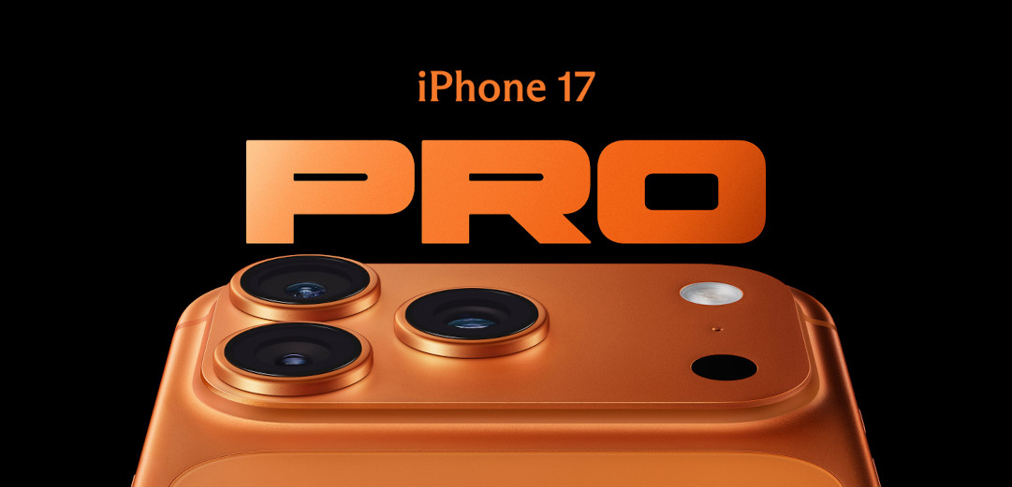

FEATURED DEAL
Name: GlassesUSA

Offer Title: 40% off frames inc designers, plus free Rx lenses & free shipping.

Redemption URL: https://glassesusa.7eer.net/c/24547/2182240/1546

Promo Code: ACCESS40

Short Description: GlassesUSA.com is the fastest growing, leading online eyewear retailer in the US offering a variety of high-quality designer brands and established house brands in a wide-range of styles – single vision glasses, multifocals, sunglasses, sports glasses, kids glasses, contact lenses, digital protection and more - GlassesUSA.com was built on the belief that purchasing eyewear shouldn't break the bank and is on a mission to change the way consumers purchase eyewear.

Logo: https://static.accessdevelopment.com/brand/911f783edd6bed325326193591090258f08b7e61/GlassesUSA_Logo.png

Expiration Date: 12/31/2025

T&C: Includes designer brands & in-house collections. Excluding: Ray-Ban, Oakley, Persol, Costa Del Mar, Prada, Luxury, and Contact lenses. Offer may not be valid with other sales/promotions. Void if altered, transferred, purchased or sold; use for these purposes is illegal and constitutes fraud. Other restrictions may apply. Offers are subject to change without notice. No cash value. © Access Development. All rights reserved. www.accessdevelopment.com



FEATURED DEAL
Name: Sandbox VR

Offer Title: Up to 20% off for 2, 4 or 6 Person VR Space

Redemption URL: https://go.launchingdeals.com/ARAQYZD

Short Description: At Sandbox VR, groups of up to six friends freely roam VR spaces together, exploring virtual worlds and relying on each other to succeed in games specifically designed to be social experiences. When guests step into our virtual worlds, they experience the world’s most advanced virtual reality.

Logo: https://static.accessdevelopment.com/brand/c5ca7470d3475aee0e00a2935167d7657b40f6b3/SandboxVR_Logo_300x300_10132025.png

Expiration Date: 12/31/2025

T&C: All sales are final and non-refundable unless specified otherwise. Powered by Access. Valid only at the location listed. Only one offer may be redeemed per visit. Offer may not be valid with other sales/promotions. Void if altered, transferred, purchased, or sold; use for these purposes is illegal and constitutes fraud. Other restrictions may apply. Offers are subject to change without notice. No cash value. © Access Development. All rights reserved. www.accessdevelopment.com

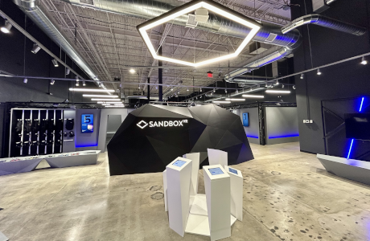

FEATURED DEAL
Name: Chicago Steak Company

Offer Title: Receive 4 Free 8oz Ribeyes with Your Order of $159+

Redemption URL: https://fmtc.co/48114437/d99f47ec361410ac5ecb5c798fb641d1?sid=ADD_CVT

Promo Code: 4RIBEYES

Short Description: At Chicago Steak Company, we invite you to taste tradition. Since 1865 with the founding of the Union Stock Yards, Chicago has been at the heart of high-quality American meats. Chicago Steak Company proudly carries on that tradition. We specialize in hand-cut, Mid-West raised, USDA Prime beef - in short, the very best steaks your money can buy. We raise, trim, and age our steaks using centuries-old techniques, then vacuum-seal each individually, locking in flavor and freshness.

Logo: https://static.accessdevelopment.com/brand/046c85aaf17a70ac04ab1dade25aeb8d64f9c0dc/chicagoSteakCo-30367093-300x300.png
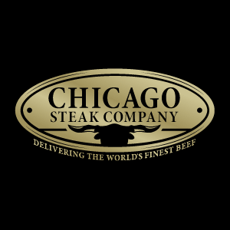
Expiration Date: 12/31/2025

T&C: Terms and Exclusions Apply, See Site for Details. Powered by Access. Valid only at the location listed. Only one offer may be redeemed per visit. Offer may not be valid with other sales/promotions. Void if altered, transferred, purchased or sold; use for these purposes is illegal and constitutes fraud. Other restrictions may apply. Offers are subject to change without notice. No cash value. © Access Development. All rights reserved. www.accessdevelopment.com

