FEATURED DEAL
Name: 1-800-GOT-JUNK

Offer Title: Members save 7% on junk removal.

Redemption URL: https://www.dpbolvw.net/click-7273667-13901274?sid=10834033

Short Description: It's never been this easy to remove unwanted items from your home or office. Just call or book online to schedule

Logo: https://static.accessdevelopment.com/brand/afd886be8a09effc6e651c03acb58ce4355ee74a/original.png

Expiration Date: 1/31/2026

T&C: Powered by Access. Offer may not be valid with other sales/promotions. Void if altered, transferred, purchased or sold; use for these purposes is illegal and constitutes fraud. Other restrictions may apply. Offers are subject to change without notice. © Access Development. All rights reserved. www.accessdevelopment.com



FEATURED DEAL
Name: Factor Meals

Offer Title: 50% Off First Box + Free Shipping + 10% off the next 12 boxes + Free Add-on Item For Life

Redemption URL: https://factorus.sjv.io/c/24547/3278809/41435?subId1=ADD_CVT

Promo Code: AVGFJ50FH

Short Description: Factor provides fresh, chef-crafted, ready-made meals that are delivered right to your doorstep. We use the freshest ingredients from our network of trusted partners to ensure that we are providing you with meals that are free of hormones, antibiotics, refined sugars, and GMOs. Your order is delivered fresh, never frozen, and only requires a few minutes in the microwave or oven before it is ready to be served and enjoyed.

Logo: https://static.accessdevelopment.com/brand/5a59debf4b0b2af2cde954770848a65e9c11ba09/Factor_Logo_300X300.png

Expiration Date: 1/31/2026

T&C: Offer can only be used once for customers with an account that was deactivated over 270 days prior to redemption or new customers with qualifying auto-renewing subscription purchase. Offer expires 112 days after offer purchase at 11:59 PM ET. Take 50% off your first box and 10% off the next 12 boxes, including free shipping on the first box. Discounts vary for other meal plans and sizes. Offer not valid on premiums, meal upgrades, add-ons, taxes or shipping fees. May not be combined with gift cards or any other promotion. No cash value. Void outside the U.S. and where prohibited. Offer cannot be sold or otherwise bartered. Factor has the right to end or modify any offer at any time. Additional restrictions may apply. See https://www.factor75.com/terms for more details. Powered by Access. Only one offer may be redeemed per visit. Offer may not be valid with other sales/promotions. Void if altered, transferred, purchased or sold; use for these purposes is illegal and constitutes fraud. Other restrictions may apply. Offers are subject to change without notice. No cash value. © Access Development. All rights reserved. www.accessdevelopment.com



FEATURED DEAL
Name: Sparefoot Storage Finder

Offer Title: Find and reserve storage in minutes and get a $20 Visa Gift Card.

Redemption URL: https://www.sparefoot.com/?stid=399

Short Description: SpareFoot.com is the largest marketplace for storage, making it easier to move and store your stuff. The SpareFoot website lets you find and compare the best storage deals near you, and instantly rent online or by phone for free. With the most up-to-date information on storage available, SpareFoot makes finding your stuff a home the easiest thing to cross off your to-do list.

Logo: https://static.accessdevelopment.com/brand/8741ee2013ce315719e203169be067da39770e3a/SpareFoot_logo_300x300.png

Expiration Date: 1/31/2026

T&C: Valid on new reservations only. You will automatically receive the gift card via email by the 17th day of the month following your completed move-in. Powered by Access. Valid only at the location listed. Only one offer may be redeemed per visit. Offer may not be valid with other sales/promotions. Void if altered, transferred, purchased or sold; use for these purposes is illegal and constitutes fraud. Other restrictions may apply. Offers are subject to change without notice. No cash value. © Access Development. All rights reserved. www.accessdevelopment.com



FEATURED DEAL
Name: Rosetta Stone

Offer Title: Get a Lifetime Subscription with Unlimited Languages for $149. Normally $399. No Renewal Fee.

Redemption URL: https://go.launchingdeals.com/BCE29PG

Short Description: Rosetta Stone has been the most trusted name in language learning for over 25 years, offering effective, expert-crafted courses in 20+ languages including Spanish, French, Japanese, and Arabic.
At Rosetta Stone, we believe the best way to pick up a language is to surround yourself with it. With immersive lessons, pronunciation feedback, real-world scenarios, and live coaching from native speakers, Rosetta Stone has empowered schools, businesses, government organizations, and millions of individual learners to not only speak fluently and confidently, but also read, write, and think in new languages.

Logo: https://static.accessdevelopment.com/brand/346bfe108dfa21e56b224b3da558d5f1231565e5/RosettaStone_19009655_11022022.png
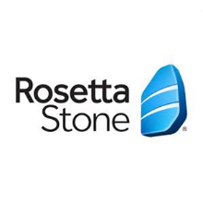
Expiration Date: 1/31/2026

T&C: See website for details. Powered by Access. Only one offer may be redeemed per visit. Offer may not be valid with other sales/promotions. Void if altered, transferred, purchased, or sold; use for these purposes is illegal and constitutes fraud. Other restrictions may apply. Offers are subject to change without notice. No cash value. © Access Development. All rights reserved. www.accessdevelopment.com



FEATURED DEAL
Name: EOS Fitness

Offer Title: Exclusive Offer On Our Best Membership: 99% off enrollment fee + 25% off monthly dues.

Redemption URL: https://www.eosfitness.com/join-now/accesseos

Short Description: EōS Fitness, a leader in the fitness industry with its High Value. Low Price. (HVLP)® gyms, is an inclusive and welcoming organization committed to empowering exercise practitioners of all experience levels. With more than 150+ locations open or on the way in Arizona, Florida, Nevada, Southern California, Texas and Utah, EōS Fitness is rapidly expanding. Providing serious fitness options, EōS Fitness offers the best equipment, high-energy workout classes, top-notch amenities, and extensive personal training options starting at just $9.99 per month. www.EoSfitness.com.

Logo: https://static.accessdevelopment.com/brand/23e18eeaf60f2fdd7a971fe18ade7b2a40538635/EOS_Logo_300x300_01132025.png

Expiration Date: 1/31/2026

T&C: Offer not available to current EōS Fitness members. Amenities vary by location. Offer only available online. Some restrictions may apply. $49.99 Annual Membership Fee applies. Powered by Access. Only one offer may be redeemed per visit. Offer may not be valid with other sales/promotions. Void if altered, transferred, purchased, or sold; use for these purposes is illegal and constitutes fraud. Other restrictions may apply. Offers are subject to change without notice. No cash value. © Access Development. All rights reserved. www.accessdevelopment.com



FEATURED DEAL
Name: PODS

Offer Title: 10% off a local move.

Redemption URL: http://www.pods.com/access

Promo Code: ACCESS

Short Description: PODS offers you a cost saving and convenient alternative to moving and storage of you household goods. Whether you're moving across town or across country, we provide you with a level of control and flexibility traditional moving and truck rental companies just can't compete with. You decide when and where you want the container delivered, picked up and delivered to your new destination. We can also store your goods in one of our centrally located, secure and accessible storage centers for extremely cost effective short or long term storage. PODS can also provide labor services to help pack, load and unload, as well as ship moving supplies and boxes right to your door. We can even arrange to have your car transported.

Logo: https://static.accessdevelopment.com/brand/4dbce8dd64d31f88b46ecc9dbeaf71b83d824da4/Pods_logo_300x300.png
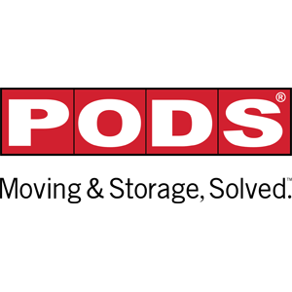
Expiration Date: 1/31/2026

T&C: Offer void where prohibited by law. Must mention promotional code at time of order. Additional mileage charges may apply if outside our standard delivery area. Please call 1-866-846-0900. For local moves, 10% off initial local delivery and first month's storage. Powered by Access. Valid only at the location listed. Only one offer may be redeemed per visit. Offer may not be valid with other sales/promotions. Other restrictions may apply. Offers are subject to change without notice. No cash value. © Access Development. All rights reserved. www.accessdevelopment.com



FEATURED DEAL
Name: Penny Finance

Offer Title: Get 60% off your annual or monthly Penny membership.

Redemption URL: https://www.penny-finance.com/quiz?utm_source=access&utm_medium=perks

Promo Code: ACCESS60

Short Description: Access personalized financial planning, actionable money insights, and self-guided education with Penny Finance. Penny offers 70+ tailored financial modules and calculators that focus on saving, spending, debt management, investing, taxes, family planning, and retirement.

Logo: https://static.accessdevelopment.com/brand/7e22288bba18431ce7fe1f6352641b4de23fdc7b/PennyFinance_437299973.png

Expiration Date: 1/31/2026

T&C: For full terms and conditions visit https://www.penny-finance.com/terms
Powered by Access. Only one offer may be redeemed per visit. Offer may not be valid with other sales/promotions. Void if altered, transferred, purchased, or sold; use for these purposes is illegal and constitutes fraud. Other restrictions may apply. Offers are subject to change without notice. No cash value. © Access Development. All rights reserved. www.accessdevelopment.com



FEATURED DEAL
Name: VIVA Finance

Offer Title: Personal loans based on employment, with instant $20 loan credit.

Redemption URL: https://dashboard.viva-finance.com/register?partner=AccessDevelopment&campaignId=d050fa30-58c1-4396-9932-c0178a81104e&redirect=https://lending.viva-finance.com/apply

Promo Code: Access20

Short Description: Fast and affordable personal loans based on employment, instead of just your credit score. Apply in minutes and receive funds as soon as the next business day. $20 loan credit automatically applied for Access members. Trusted by thousands of employees, with over 1,000 five-star reviews. Consolidate debt, catch up on bills, and more.

Logo: https://static.accessdevelopment.com/brand/d60e8313185a46c77129ab10aab7842058745498/VIVAFinance_434434086.png

Expiration Date: 1/31/2026

T&C: $20 credit will be applied to customer’s loan as a principal payment. This will save the customer money on any interest that would have accrued on the additional $20 balance. Customer must either apply using the offer link or include the promo code in his or her application for the credit to be applied. Powered by Access. Only one offer may be redeemed per visit. Offer may not be valid with other sales/promotions. Void if altered, transferred, purchased, or sold; use for these purposes is illegal and constitutes fraud. Other restrictions may apply. Offers are subject to change without notice. No cash value. © Access Development. All rights reserved. www.accessdevelopment.com

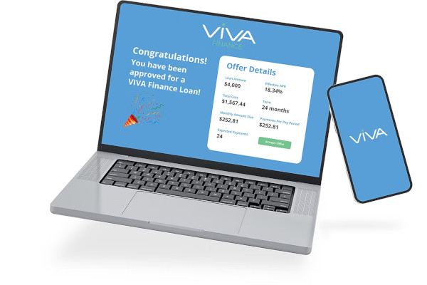

FEATURED DEAL
Name: Weight Care

Offer Title: $300 off the Semaglutide Program.

Redemption URL: https://joinweightcare.com/ACCESS300

Promo Code: ACCESS300

Short Description: WeightCare provides a simplified solution to medically supervised weight loss that is accessible, affordable, and effective. Members have instant access to physicians specialized in weight loss along with ongoing support to assist them throughout their journey.

Logo: https://static.accessdevelopment.com/brand/afd73304c9ebb5f068c06c82a3be676069108a96/WeightCare_Logo_300X300.png

Expiration Date: 1/31/2026

T&C: We are able to serve customers in all states except AK, AL, AR, HI, MI, and MS. Limit of 1 deal per customer. The discount is for the first month only! Powered by Access. Only one offer may be redeemed per visit. Offer may not be valid with other sales/promotions. Void if altered, transferred, purchased, or sold; use for these purposes is illegal and constitutes fraud. Other restrictions may apply. Offers are subject to change without notice. No cash value. © Access Development. All rights reserved. www.accessdevelopment.com



