FEATURED DEAL
Name: Costco

Offer Title: Join as a new Executive and enroll in auto renewal to receive a $40 Digital Costco Shop Card.

Redemption URL: https://costco.prf.hn/click/camref:1100l5IZTP/creativeref:1101l199543

Redeem Instructions: Click link and offer should automatically apply

Offer Key: 485184927

Short Description: Looking for quality, value and convenience? Think Costco.
Costco is a membership club and committed to providing high-quality goods and services at an incredible value for its members. You'll find everything you need from school supplies and organic foods and snacks, to laptops and electronics with the latest technology.
Shop confidently, online or in person, knowing that Costco is a company with a conscience and continues to adapt as we learn about our global impact with a commitment to sustainability. The ways that Costco can fit your lifestyle are endless. Find out what more than 100 million Costco members already know and join today.

Logo: https://static.accessdevelopment.com/brand/9f4c477b8809a6fe623a679b60243dd3972d340e/Costco_18938349_07062023.png

Expiration Date: 07/31/2026

T&C: *To receive a Digital Costco Shop Card, you must provide a valid email address and set up auto renewal of your Costco membership on a Visa® credit/debit card or Mastercard debit card at the time of sign-up. If you elect not to enroll in auto renewal at the time of sign-up, incentives will not be owed.
Valid only for new members and those who have not been a Costco member (in any capacity, Primary, Household, or Affiliate) in the last 18 months. Valid only for nonmembers for their first year of membership. Not valid for upgrade or renewal of an existing membership. Promotion may not be combined with any other promotion. Costco employees are not eligible for new member promotions. Digital Costco Shop Card will be emailed to the email address provided by the Primary Member at time of sign-up within 2 weeks after successful sign-up and enrollment in auto renewal. Digital Costco Shop Card is not redeemable for cash, except as required by law. Costco is not liable for incentives not received due to entry of an invalid address during sign-up. Digital Costco Shop Cards are not accepted at the U.S. or Canada Food Court. Neither Costco Wholesale Corporation nor its affiliates are responsible for use of the card without your permission. Use the provided single-use promo code when entering your payment information. A Costco Gold Star Membership is $65 a year. An Executive Membership is an additional $65 upgrade fee a year. Each membership includes one free Affiliate Card. May be subject to sales tax. Costco accepts all Visa cards, as well as cash, checks, debit/ATM cards, EBT and Costco Shop Cards. Departments and product selection may vary.
Powered by Access. Offer may not be valid with other sales/promotions. Void if altered, transferred, purchased or sold; use for these purposes is illegal and constitutes fraud. Other restrictions may apply. Offers are subject to change without notice. No cash value. © Access Development. All rights reserved. www.accessdevelopment.com

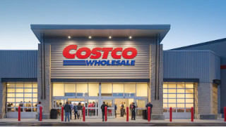

FEATURED DEAL
Name: Texas de Brazil

Offer Title: 15% off regular-priced dinner.

Redemption Link: Put this extension at the end of your savings program URL
/director?view=offer&offer_key=284090940

Offer Key: 284090940

Short Description: In southern Brazil, local cowboys called gauchos prepare legendary feasts in a tradition known as churrasco. They slow-roast meats over open flames and present an impressive display of seasonal greens, vegetable dishes and regional delicacies. The succulent meats are brought to each group's table and carved in a show of skill and festive offering. At Texas de Brazil, we continue this treasured tradition. Treat yourself to a wide array of chef-crafted salads, roasted vegetables, imported cheeses and charcuterie. Enjoy house-baked cheese bread, garlic mashed potatoes and fried bananas. Turn your card to green, and expert carvers generously serve you sizzling beef, lamb, pork, chicken and Brazilian sausage. Simply turn your card to red to take a break. Liven up your meal by ordering our signature cocktail – the Caipirinha. And remember, our servers are always standing by to accommodate any request.

Logo: https://static.accessdevelopment.com/brand/505f832bca8c4a7d8d92c946dbecb17531ba0519/original.png

Expiration Date: 07/31/2026

T&C: Valid Monday – Thursday for up to 8 guests per table/reservation. Not valid on restaurant holidays, with any other offer or our white gift cards. Desserts, beverages, tax and gratuity are not included. Valid at locations within the continental US only. Powered by Access. Valid only at the location listed. Only one offer may be redeemed per visit. Offer may not be valid with other sales/promotions. Void if altered, transferred, purchased or sold; use for these purposes is illegal and constitutes fraud. Other restrictions may apply. Offers are subject to change without notice. No cash value. © Access Development. All rights reserved. www.accessdevelopment.com

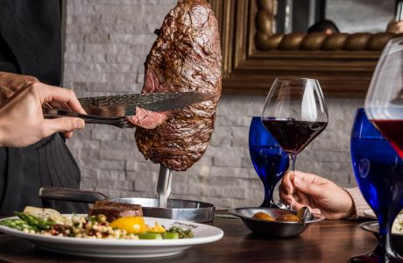

FEATURED DEAL
Name: Bass Pro Shops

Offer Title: Save up to 40% with Bass Pro Shops Star Spangled Summer Sale and get an additional $15 off $100, $30 off $200, or $45 off $300 with exclusive offer.

Redemption URL: Add this extension to the end of your savings program URL
/director?view=offer&offer_key=481164257

Offer Key: 481164257

Short Description: Bass Pro Shops is your premier retailer for outdoor gear and adventure. Trusted for quality products, expert guidance, and an unwavering commitment to conservation. Explore with us, knowing your passion supports the preservation of our natural world for generations to come.

Logo: https://static.accessdevelopment.com/brand/5e821c6f5960357c282ddd661ee5195c2972ac24/BassProShops_418201234_300x300.png

Expiration Date: 07/31/2026

T&C: Exclusions on guns, ammo, sunglasses, gift cards, or Jon Boats. <br><br>Powered by Access. Valid only at the location listed. Only one offer may be redeemed per visit. Offer may not be valid with other sales/promotions. Void if altered, transferred, purchased or sold; use for these purposes is illegal and constitutes fraud. Other restrictions may apply. Offers are subject to change without notice. No cash value. © Access Development. All rights reserved. www.accessdevelopment.com



FEATURED DEAL
Name: Quiznos

Offer Title: Free chips and regular fountain drink with purchase of regular or large sub or full salad.

Redemption URL: Add this extension to the end of your savings program URL
/director?view=offer&offer_key=469686206

Offer Key: 469686206

Short Description: Quiznos serves toasty sub sandwiches for lunch or dinner. Our sandwiches are made with the highest quality ingredients, freshly sliced meats, cheeses and vegetables. Toasting our sandwiches makes them taste even better; it releases the flavors from our meats and cheeses. Quiznos sandwiches, salads and pastas are available for takeout, delivery and catering. Quiznos.MMMMM...TOASTY

Logo: https://static.accessdevelopment.com/brand/cb03a09fc40651b6cd4fc0b9902982da0ca70c91/original.png

Expiration Date: 07/31/2026

T&C: Valid only at participating US or listed Quiznos®. Coupon must be surrendered at time of purchase. One coupon per person per order. Value of promotional items may vary. May not be valid for custom orders or combined with any other offers. Taxes excluded. No cash value (unless prohibited by law, then cash value is $.005). No substitutions. Void if copied or transferred and where prohibited. Limited delivery areas. Order requirements and delivery fees may apply. Not valid with Deal of the Day. Powered by Access. Valid only at the location listed. Only one offer may be redeemed per visit. Offer may not be valid with other sales/promotions. Void if altered, transferred, purchased or sold; use for these purposes is illegal and constitutes fraud. Other restrictions may apply. Offers are subject to change without notice. No cash value. © Access Development. All rights reserved. www.accessdevelopment.com
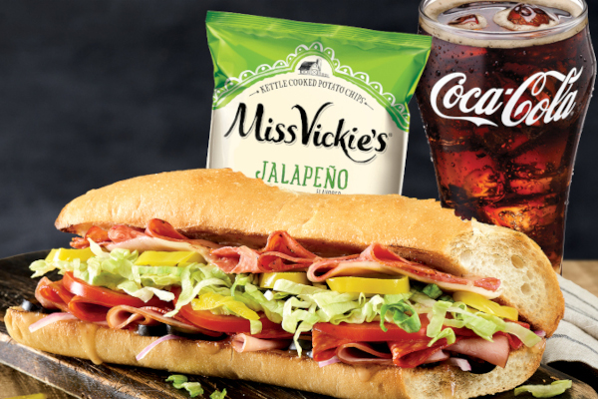

FEATURED DEAL
Name: Columbia Sportswear

Offer Title: 10% off.

Redemption URL: https://www.jdoqocy.com/click-7273667-12416259?sid=ADD_CVT

Redeem Instructions: Click link and discount will automatically be applied

Offer Key: 283204506

Short Description: Since 1938, Columbia Sportswear has been focused on creating authentic, innovative products for passionate outdoor lovers - people like you. We Believe achieving a 70-year history of industry leading outdoor apparel and product takes passion, and an understanding of people who love the outdoors as much as we do. That's why, from cutting edge Titanium pieces, to our innovative heritage in Bugaboo, our jackets, pants, fleece, boots & shoes are all tested tough so you can enjoy the outdoors longer. We're committed to helping get more people outside, more often. We make high-quality performance products that keep you comfortable and protected, no matter where your excursions take you. Welcome to the Greater Outdoors. Now get out there!

Logo: https://static.accessdevelopment.com/brand/7934676e53a08305fac1b1b4be98e370f0310b54/original.png

Expiration Date: 07/31/2026

T&C: These links are provided as a courtesy to our valued members. The offers are not exclusive, but are the best value at the store right now. This offer contains affiliate links. Powered by Access. Valid only at the location listed. Only one offer may be redeemed per visit. Offer may not be valid with other sales/promotions. Void if altered, transferred, purchased or sold; use for these purposes is illegal and constitutes fraud. Other restrictions may apply. Offers are subject to change without notice. No cash value. © Access Development. All rights reserved. www.accessdevelopment.com

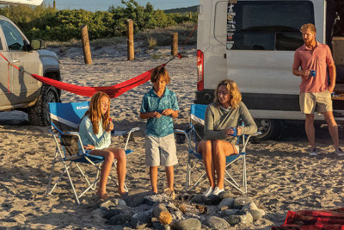

FEATURED DEAL
Name: Mountain Warehouse

Offer Title: 15% off $50+ Orders

Redemption URL: https://fmtc.co/48473742/d99f47ec361410ac5ecb5c798fb641d1?sid=ADD_CVT

Promo Code: AFF1550NA

Redeem Instructions: Click link and use promo code

Offer Key: 483981114

Short Description: Mountain Warehouse is a specialist chain retailer selling clothing, shoes and gear for outdoor, leisure and sporting activities for the entire family. We pride ourselves on offering the highest quality products at the lowest possible prices. Safe payment with popular payment options like AMEX, PAYPAL and VISA. Speedy and reliable shipping direct from our North American warehouse. Friendly and helpful customer service. A hassle-free returns policy if you decide to change your mind - for whatever reason.

Logo: https://static.accessdevelopment.com/brand/3f24a05a2da009b3bd4e72aeb3e6df9edb7e9545/mountainWarehouse-logo-green-300x300.png

Expiration Date: 07/31/2026

T&C: Powered by Access. Valid only at the location listed. Only one offer may be redeemed per visit. Offer may not be valid with other sales/promotions. Void if altered, transferred, purchased or sold; use for these purposes is illegal and constitutes fraud. Other restrictions may apply. Offers are subject to change without notice. No cash value. © Access Development. All rights reserved. www.accessdevelopment.com



FEATURED DEAL
Name: Carvel

Offer Title: BOGO Classic Sundaes: Buy one, get one free.

Redemption URL: Add this extension to the end of your savings program URL
/director?view=offer&offer_key=459445122

Offer Key: 459445122

Short Description: Inventing Originals since 1934. Treat yourself to a softer world with our classic soft-serve ice cream and iconic treats like our signature Fudgie the Whale® and Cookie Puss® ice cream cakes! Carvel's ice cream products are always hand crafted in-shoppe making our original soft-serve ice cream a labor of love with a smooth and creamy flavor that can't be matched. Discover the magic of Carvel today and taste the difference!

Logo: https://static.accessdevelopment.com/brand/fefbbb448f555b4980d642bdd070bf0b32b8e507/CarvelLogo_300X300.png

Expiration Date: 07/31/2026

T&C: Cashier Redemption Instructions
1. Press item to coupon on tally screen
2. Press DISCOUNT ITEM on discount screen
3. All discounts and applicable coupons will appear, press the correct one for the product.
4. Press OK to apply
Discount applies to Classic Sundae of equal or lesser value (extra toppings not included). Valid in shoppe only at participating Carvel locations. Visit carvel.com/locations to find a shoppe in your area. Not valid with any other offer. One coupon per transaction, per visit. Exclusive of tax and gratuity. Sale, resale and/or internet distribution strictly prohibited. Void where prohibited. Cash value 1/100¢. No cash back. Additional exclusions may apply. Powered by Access. Valid only at the location listed. Only one offer may be redeemed per visit. Offer may not be valid with other sales/promotions. Void if altered, transferred, purchased or sold; use for these purposes is illegal and constitutes fraud. Other restrictions may apply. Offers are subject to change without notice. No cash value. © Access Development. All rights reserved. www.accessdevelopment.com


FEATURED DEAL
Name: Backcountry.com

Offer Title: 20% off each eligible item in your Backcountry.com cart

Redemption URL: Add this extension to the end of your savings program URL
/director?view=offer&offer_key=461985850

Offer Key: 461985850

Short Description: Backcountry.com offers the highest quality gear for backpacking, hiking, camping, trail running, skiing, snowboarding, rock climbing, fly fishing, overlanding, kayaking, mountain biking and more. Outdoor gear and clothing from big brands to the small and undiscovered. Backcountry was born from a love of gear and a passion for exploring. We go to extraordinary lengths to understand and serve every unique customer and prospect.

Logo: https://static.accessdevelopment.com/brand/1995850698dc3df96c95f514f399804011957cd4/Backcountry_Logo_300X300_2.png

Expiration Date: 07/31/2026

T&C: • Must apply promo code at checkout to redeem at backcountry.com
• Offer valid for 20% off each eligible item in your Backcountry.com cart.
• If the coupon code does not apply to the product it is not eligible for the discount.
• Offer valid for a limited time, and may not be combined with any other discount or offer. Limit one use per customer.
• Coupon offers are not stackable (i.e. multiple coupon codes cannot be applied to a single order) and the most recently applied coupon will always be applied.
• Offer is limited to stock on hand; offer is nontransferable and is not redeemable for cash.
Offer limited to 3 units per style.
• Offer not valid on gift cards, charitable contributions, packaging, taxes, shipping and any special-order handling charges.
• This offer is exclusive to you and cannot be reproduced, transferred, or used by anyone else.
• Backcountry reserves the right to modify or terminate this offer at any time without notice.
• For more information about this offer, email service@backcountry.com, or select the chat icon at www.backcountry.com
Powered by Access. Valid only at the location listed. Only one offer may be redeemed per visit. Offer may not be valid with other sales/promotions. Void if altered, transferred, purchased or sold; use for these purposes is illegal and constitutes fraud. Other restrictions may apply. Offers are subject to change without notice. No cash value. © Access Development. All rights reserved. www.accessdevelopment.com



FEATURED DEAL
Name: Panera Bread

Offer Title: $7.50/month for 5 months of Unlimited Sip Club

Redemption URL: https://www.panerabread.com/en-us/mypanera/subscription/half-sips.html?promocode=HALFSIPS

Promo Code: HALFSIPS

Redeem Instructions: Click link and use promo code

Offer Key: 477691727

Short Description: Keep your cup full with Panera's Unlimited Sip Club. Enjoy select lemonades, coffees, teas, or fountain beverages every two hours when you redeem your subscription on the Panera app or keep the unlimited refills coming while you're in a cafe.

Logo: https://static.accessdevelopment.com/brand/663078b7c415c8965932636d25bd0aef60f700dc/PaneraBread_Logo_300x300_08132025.png

Expiration Date: 07/31/2026

T&C: New and lapsed subscribers who sign up for a monthly Unlimited Sip Club subscription from 12:00am PT on October 15, 2025 through 11:59pm PT December 31, 2026 and enter promo code HALFSIPS at signup will receive five months of an Unlimited Sip Club subscription for $7.50/ month plus tax. A new subscriber is a person that has never had an Unlimited Sip Club subscription through any name, email address, address, or phone number. A lapsed subscriber is a person that has previously had, but no longer has, an active Unlimited Sip Club reward on their MyPanera account through any name, email address, address, or phone number. You must enter promo code HALFSIPS to receive this offer. Code will not be automatically applied. Offer will be revoked if Panera determines, in its sole discretion, that person has another active Unlimited Sip Club subscription. Not valid with any other coupon or offer. Offer may expire or be terminated by Panera without notice due to error, fraud, computer error, electronic or technical malfunctions, or other unusual or unexpected circumstances. Other restrictions may apply. General Unlimited Sip Club Terms: Unlimited Sip Club subscription is available for registration and redemption in participating US cafes. Must be MyPanera member and at least 18 years of age to register. Registration available online only (including in-cafe kiosk). You may cancel at any time. If you do not cancel either before your renewal date or the expiration of any promotional or trial subscription offer, your stored payment method will automatically be charged $14.99 plus tax for a monthly subscription and will be charged on a recurring monthly basis every 30 days thereafter unless you cancel your subscription. To cancel subscription online, visit Manage Subscription section at www.panerabread.com/UnlimitedSipClub or on the Panera app. Subscription provides eligible subscribers the following subscription benefits: drip hot coffee, iced coffee, hot tea, fountain soda beverages, and select bubbler beverages (not all bubbler beverages are included in the Subscription) once every two hours during normal cafe business hours, including free refills if applicable (some beverages are not eligible for free refills). The number and type of eligible beverages may vary by location and time of day. Excludes all other beverages, including, without limitation, Energy Refreshers, Frescas, packaged beverages, smoothies, frozen blended drinks, hot chocolate, cold brew iced coffee, and espresso and cappuccino beverages, and select bubbler beverages. Customizations, including, without limitation, added espresso and syrups (e.g., vanilla, chocolate, cinnamon, and caramel) are not included in subscription monthly price. Upcharges apply. Other additions (e.g., milk, skim milk, almond milk, half & half, and sweeteners) are included in monthly subscription price but availability may vary by location and time of day. Limit one subscription per person. Excludes catering orders and orders placed on third-party delivery sites. Panera reserves the right in its sole discretion to offer additional or different subscription benefits to members based on geographic location, home bakery-cafe, program participation, period of recurring subscription, or other criteria. Other restrictions may apply. Visit here for complete terms: https://www.panerabread.com/en-us/mypanera/subscription/terms-and-conditions.html. Powered by Access. Offer may not be valid with other sales/promotions. Void if altered, transferred, purchased, or sold; use for these purposes is illegal and constitutes fraud. Other restrictions may apply. Offers are subject to change without notice. No cash value. © Access Development. All rights reserved. www.accessdevelopment.com

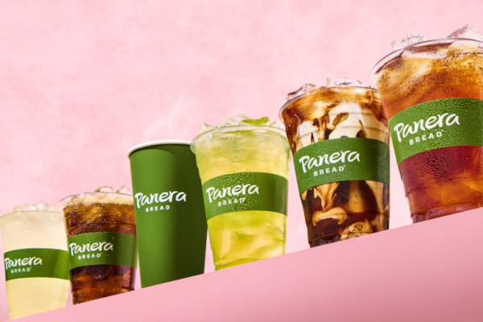

FEATURED DEAL
Name: FishUSA

Offer Title: 10% OFF FishUSA Branded Products

Redemption URL: https://www.avantlink.com/click.php?tool_type=cl&merchant_id=7d037111-c72f-44d2-98cb-908694f2097b&website_id=06a62b73-76c1-4775-998d-060d3a11792d&url=https%3A%2F%2Fwww.fishusa.com%2Ffishusa%2F

Promo Code: accessflagship

Redeem Instructions: Click link and use promo code

Offer Key: 414693317

Short Description: FishUSA® is America’s Tackle Shop®, offering anglers the best selection of premium fishing tackle & gear, expert advice, and outstanding customer service since 2000. Based in Fairview, Pennsylvania, FishUSA.com is a leading online retailer specializing in freshwater and saltwater tackle for anglers of all skill levels. Whether you're chasing steelhead in the Great Lakes, bass in southern reservoirs, or walleye through the ice, FishUSA delivers top-quality rods, reels, lures, lines, and accessories from the most trusted brands in the industry.
With a deep commitment to the fishing community, FishUSA supports conservation efforts, sponsors local tournaments, and partners with charter captains and tackle shops through its Wholesale Program. Passionate anglers can also shop in person at FishUSA’s Pro Shop, located in Fairview, for a hands-on experience and guidance from seasoned staff.
At FishUSA, fishing isn't just a hobby—it's a way of life. From beginners to pros, FishUSA helps every angler fish their passion.

Logo: https://static.accessdevelopment.com/brand/2dbeaebb6af438622fdf120bc3d4d5bfb1cc31c7/FishUSA_Logo.png

Expiration Date: 07/31/2026

T&C: Gift Cards excluded. Powered by Access. Valid only at the location listed. Only one offer may be redeemed per visit. Offer may not be valid with other sales/promotions. Void if altered, transferred, purchased or sold; use for these purposes is illegal and constitutes fraud. Other restrictions may apply. Offers are subject to change without notice. No cash value. © Access Development. All rights reserved. www.accessdevelopment.com

