FEATURED DEAL
Name: Topgolf

Offer Title: $15 off Topgolf game play.

Redemption URL: Add this extension to the end of your savings program URL /director?view=location&location_key=5744730

Redeem Instructions: TO REDEEM, APPLY CODE ON THE GAME PANEL IN YOUR BAY WHEN INITIALLY SELECTING GAME TIME

Offer Key: 466283674

Short Description: Topgolf is a global sports and entertainment community connecting fans in meaningful ways through the experiences we create, the innovation we champion and the good that we do. Because we believe in creating moments that matter for everyone.

Logo: https://static.accessdevelopment.com/brand/46981eb41f49b064e382c9e13734253811b1cd31/TopGolf_logo_300x300.png

Expiration Date: 6/30/2026

T&C: Valid for $15 off Topgolf game play. Cannot be used in conjunction with any other coupon, offer or promotion, and not valid for use on parties or events. May be used only once and applied to only one (1) membership. Only one (1) coupon may be used per group/bay. Any unused value will be forfeited. Cannot be substituted and has no cash value. Must be redeemed at the venue. Excludes Lounge, Swing Suite and Toptracer Range locations. TO REDEEM, APPLY CODE ON THE GAME PANEL IN YOUR BAY WHEN INITIALLY SELECTING GAME TIME. Powered by Access. Valid only at the location listed. Only one offer may be redeemed per visit. Offer may not be valid with other sales/promotions. Void if altered, transferred, purchased or sold; use for these purposes is illegal and constitutes fraud. Other restrictions may apply. Offers are subject to change without notice. No cash value. © Access Development. All rights reserved. www.accessdevelopment.com

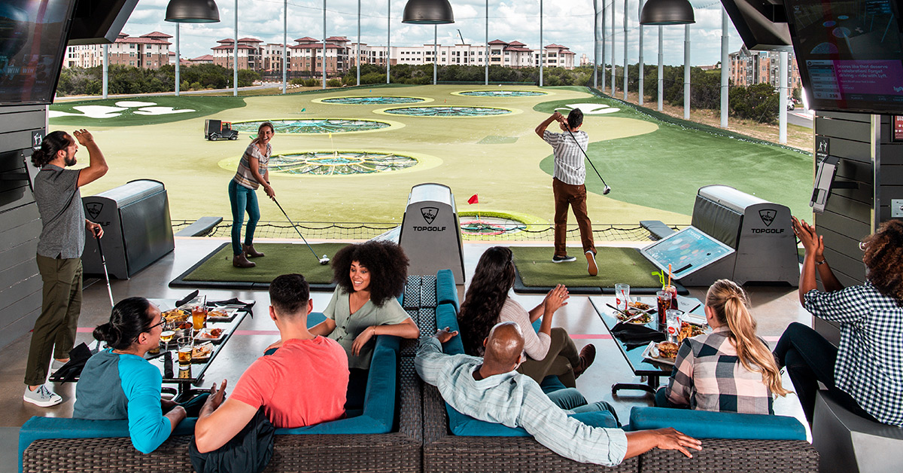

FEATURED DEAL
Name: Shake Shack

Offer Title: 20% off purchase

Redemption URL: Add this extension to the end of your savings program URL
/director?view=offer&offer_key=484196605

Offer Key: 484196605

Short Description: Shake Shack serves elevated versions of American classics using only the best ingredients. It’s known for its delicious made-to-order 100% Angus beef burgers, crispy chicken, hand-spun milkshakes, house-made lemonades, beer, wine, and more.

Logo: https://static.accessdevelopment.com/brand/e0b363912f3602182715be930dd7887501614009/ShakeShack_Logo_300x300_09112025.png

Expiration Date: 6/30/2026

T&C: Offer only valid for orders placed at a kiosk in-Shack, or for delivery or pick-up via the Shake Shack Mobile App or shakeshack.com at participating US Shake Shack locations (excluding airports, stadiums, arenas, travel plazas, and museums). Offer is valid 30 days from guest’s receipt. Offer is not valid for drive-thru or third-party delivery apps. One time use per order. Max savings of up to $20. Offer only valid for the purchase off food or beverage products (including burgers, sandwiches, fries, chicken bites, hotdogs, drinks, shakes, frozen custard, poochinis and, bag o’ bones), excluding gift cards, merchandise available on the Shack Store, and any applicable taxes or fees, including, delivery fees, service fees, or any other applicable fees. Cannot be combined with any other offers or promotions. Use unique code at checkout. Code is case sensitive. Offer code will only work in all caps.
Powered by Access. Valid only at the location listed. Only one offer may be redeemed per visit. Offer may not be valid with other sales/promotions. Void if altered, transferred, purchased or sold; use for these purposes is illegal and constitutes fraud. Other restrictions may apply. Offers are subject to change without notice. No cash value. © Access Development. All rights reserved. www.accessdevelopment.com
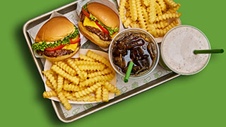

FEATURED DEAL
Name: Jamba

Offer Title: Spend $12 or more and get $2 off your purchase.

Redemption URL: https://www.jamba.com/rewards

Promo Code: ACCESS226

Redeem Instructions: How to Redeem This Offer:
1. Download or open the Jamba app. If you don't already have it download it on Google Play, or the Apple Store.
2. Once signed in, tap ‘rewards’ at the bottom of the screen.
3. Tap ‘unlock rewards card’
4. Input the reward code ACCESS226 then tap 'apply'

Offer Key: 476474215

Short Description: When you wanna feel your best, when you are flavor obsessed there's only one way to refresh, you just gotta Jamba.

Logo: https://static.accessdevelopment.com/brand/2a43dc78ed8f8a6dbcbcabf07c9be2dadbb54c0b/Jamba_Logo_300X300_06082023.png

Expiration Date: 6/30/2026

T&C: From 04/01/26 - 06/30/26, enter promo code in the Jamba Rewards Program to unlock $2 Off Order of $12+ Reward. To use, apply Reward at checkout for Orders of $12+ (excluding taxes and fees) at participating locations. Reward expires on 06/30/26. Single use. Not valid with third-party delivery. Service fee applies to online, in app, and certain call-in orders, other fees and taxes may apply; see checkout for details. Void where prohibited. The 50% off smoothie and 50% off food item offers are exclusive to new Jamba Rewards Members at participating locations. Offer valid for 50% off one (1) smoothie, excluding add-ons, taxes, and fees. Reward expires 14 days after receipt. Must apply reward at checkout. Single use. Not valid with any other offer or reward, or third-party delivery. Service fee applies to online, in app, and certain call-in orders, other fees and taxes may apply for all orders; see checkout for details. Void where prohibited. Visit https://www.jamba.com/legal for full Jamba Rewards terms and conditions. Powered by Access. Valid only at the location listed. Only one offer may be redeemed per visit. Offer may not be valid with other sales/promotions. Void if altered, transferred, purchased or sold; use for these purposes is illegal and constitutes fraud. Other restrictions may apply. Offers are subject to change without notice. No cash value. © Access Development. All rights reserved. www.accessdevelopment.com



FEATURED DEAL
Name: Chuck E. Cheese

Offer Title: Up to 49% off Family Play & Pizza Package - Valid Any Day

Redemption URL: https://go.launchingdeals.com/HAF5NGR

Redeem Instructions: Use this link and the discount will be automatically applied

Offer Key: 466147900

Short Description: Where A Kid Can Be A Kid®<br><br>Get ready for a whole new level of fun! With new and refreshed games, an interactive dance floor, live shows, awesome new prizes, and new food (including a Grown-Up menu), Chuck E. Cheese is now better than ever!

Logo: https://static.accessdevelopment.com/brand/ef5b9be13937089bb10afc73019f1208420d2ced/ChuckECheese_Logo_300x300.png

Expiration Date: 6/30/2026

T&C: Chuck E. Cheese vouchers MUST be purchased at least 24 hours before visit. Expires 90 days after purchase. No booking required, present voucher on arrival. Must be purchased 24 hours before visit. Tax is not included and will be charged at the time of visit. Valid at participating US locations only. Must use promotional value in 1 visit (does not roll over). Not valid with other offers or promotions at Chuck E Cheese. Tax not included, and will be collected upon visit. Not valid for birthday parties, group events or online ordering. The "60-Minutes of All You Can Play Games – Valid Weekdays" package is valid Monday thru Friday only. Valid only for option purchased. Merchant is solely responsible to purchasers for the care and quality of the advertised goods and services. Offer is not eligible for our promo codes or other discounts. *Savings are based on average market prices in the US. All sales are final and non-refundable unless specified otherwise. Powered by Access. Valid only at the location listed. Only one offer may be redeemed per visit. Offer may not be valid with other sales/promotions. Void if altered, transferred, purchased or sold; use for these purposes is illegal and constitutes fraud. Other restrictions may apply. Offers are subject to change without notice. No cash value. © Access Development. All rights reserved. www.accessdevelopment.com

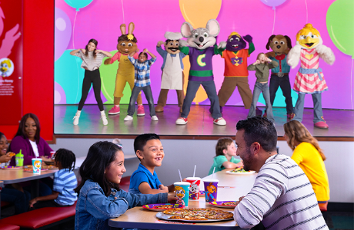

FEATURED DEAL
Name: Fubo

Offer Title: Get $25 off your first two months of Elite

Redemption URL: https://www.fubo.tv/stream/partner-offer/?irad=3301507&irmp=24547&sharedid=ADD_CVT

Redeem Instructions: Use this link and the discount will be automatically applied

Offer Key: 482848823

Short Description: Fubo is the leading sports-first live TV streaming platform built for fans who want to watch live sports without cable. Stream NFL, NBA, MLB, NHL, NCAA college football and basketball, Premier League, UEFA Champions League, MLS, F1, NASCAR, PGA Tour, WNBA, international soccer and more - all live. With 300+ live TV channels, Fubo delivers the most local sports coverage in select markets, plus top entertainment, news and movies.

Logo: https://static.accessdevelopment.com/brand/48da72f918d6119552c35055ae134d22f118a052/Fubo_Logo_300x300_02092026.png

Expiration Date: 6/30/2026

T&C: Offer valid for new Fubo subscribers only. $25 discount will be applied to each of your first 2 monthly bills for the Fubo Elite plan (total savings of $50). After the promotional period, you’ll be billed monthly at the regular Fubo Elite price plus any applicable taxes and fees. Cancel anytime. One offer per household. May not be combined with other promotions. Channel availability varies by plan and location. Regional restrictions and blackout rules apply.
Powered by Access. Only one offer may be redeemed per visit. Offer may not be valid with other sales/promotions. Void if altered, transferred, purchased, or sold; use for these purposes is illegal and constitutes fraud. Other restrictions may apply. Offers are subject to change without notice. No cash value. © Access Development. All rights reserved. www.accessdevelopment.com



FEATURED DEAL
Name: Jiffy Lube

Offer Title: 15% off your entire service order.

Redemption URL: Add this extension to the end of your savings program URL
/director?view=offer&offer_key=482269342

Redeem Instructions: To redeem, print or show the coupon at the time of purchase. Identify yourself as a National Fleet Cash Account

Offer Key: 482269342

Short Description: Taking care of your car's engine can be complicated. Luckily at Jiffy Lube, we're more than oil change experts, we're auto maintenance experts. And we offer dozens of services that keep your car and your engine running great.

Logo: https://static.accessdevelopment.com/brand/df9fd83f312ed4482d05a52f63f267415cfad881/original.png

Expiration Date: 6/30/2026

T&C: This is not a coupon; but instructions on how to attach the vehicle to the Access Development Fleet Account. Valid in US only.
Offer must be presented at time of service. This is not a coupon. This offer cannot be combined with any other offer and cannot be used on tire services, gift cards or e-gift cards. Not to be sold, transferred, reproduced or altered in any way. Void where prohibited, taxed or restricted. Cash value 1/100 ¢. Jiffy Lube® and the Jiffy Lube design mark are registered trademarks of Jiffy Lube® International, Inc. © 2026 Jiffy Lube® International, Inc. CS20625-01
Powered by Access. Valid only at the location listed. Only one offer may be redeemed per visit. Offer may not be valid with other sales/promotions. Void if altered, transferred, purchased or sold; use for these purposes is illegal and constitutes fraud. Other restrictions may apply. Offers are subject to change without notice. No cash value. © Access Development. All rights reserved. www.accessdevelopment.com
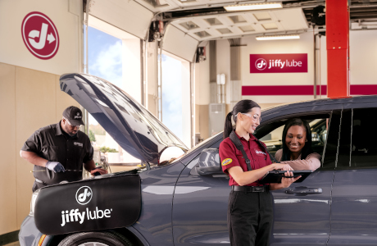

FEATURED DEAL
Name: Take 5 Oil Change

Offer Title: $20 Off Any Oil Change.

Redemption URL: Add this extension to the end of your savings program URL
/director?view=offer&offer_key=453824979

Offer Key: 453824979

Short Description: At Take 5, an oil change takes just 10 minutes, which is a lot faster than you think. Stop by today for fast, friendly, and simple car maintenance!
Appointments available at participating locations.

Logo: https://static.accessdevelopment.com/brand/da5dfbc19eea7633f11fdc4a5a33ca7097d4ca71/Take5Oil_Logo_300x300_05132026.png

Expiration Date: 6/30/2026

T&C: Some restrictions apply. See store for details. Valid for retail customers only. Limit one coupon per vehicle. No cash value. Coupon must be presented at time of service and may not be combined with other banner, coupon or discounted offers. Offer not valid on customer’s own oil or filter. Powered by Access. Valid only at the location listed. Only one offer may be redeemed per visit. Offer may not be valid with other sales/promotions. Void if altered, transferred, purchased or sold; use for these purposes is illegal and constitutes fraud. Other restrictions may apply. Offers are subject to change without notice. No cash value. © Access Development. All rights reserved. www.accessdevelopment.com

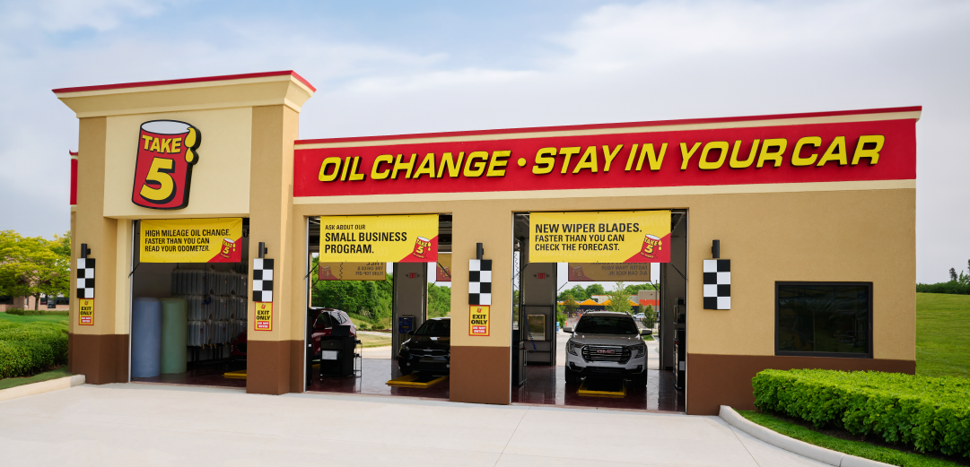

FEATURED DEAL
Name: Bowlero

Offer Title: Bowling offers for 2, 4 and 6 people (Up to 60% Off!)

Redemption URL: https://go.launchingdeals.com/5FSJ2F5

Redeem Instructions: To redeem this offer, click link to see the exclusive pricing and purchase your voucher.
Enter promo code BowlMore5 at checkout for an added 5% discount.

Offer Key: 483322664

Short Description: Bowlero brings the bowling experience to a whole new level—with blacklight lanes, interactive arcade games, and a delicious menu of wildly inventive eats. Bowlero's hip, retro-cool setting, quirky décor, and vintage style remind guests that, whenever they roll in, it's time to have fun and Be Bowled.

Logo: https://static.accessdevelopment.com/brand/a91c130631fac0b09bec436d1c8629c3f9320a99/BowleroLogo.png

Expiration Date: 6/15/2026

T&C: Promotional value expires June 29, 2026 - After the promotional value expiration date, the voucher may only be redeemed for the amount paid. Vouchers cannot be redeemed on the same date of purchase. Guests must wait 24 hrs. post-purchase to redeem. Not valid for redemption on Saturdays after 6:00pm. Only one voucher can be redeemed per visit. 1 lane per voucher used. Valid for 2 hours of bowling and shoes for the number of people associated with voucher purchase (2, 4, or 6). Vouchers cannot be used for any contracted events. To redeem, present your voucher at participating locations - Valid at select locations only. Visit https://www.bowlero.com/locations for up-to-date location information and hours of operation.
Powered by Access. Only one offer may be redeemed per visit. Void if altered, transferred, purchased, or sold; use for these purposes is illegal and constitutes fraud. Other restrictions may apply. Offers are subject to change without notice. No cash value. © Access Development. All rights reserved. www.accessdevelopment.com



FEATURED DEAL
Name: IT Luggage

Offer Title: 25% Off Sitewide

Redemption URL: https://itluggageus.sjv.io/c/24547/3036222/31249?sharedid=ADD_CVT

Promo Code: AccDev25

Redeem Instructions: Click link and use promo code at checkout

Offer Key: 483192109

Short Description: Designed in the UK and built to last. For 40 years our luggage collections have offered modern design, excellent quality & exceptional value, with styles to suit everyone.

Logo: https://static.accessdevelopment.com/brand/b4206002d63c274fe4b04889a6828f3502421137/ITLuggage_Logo_300x300_02182026.png

Expiration Date: 6/30/2026

T&C: Cannot be used in conjunction with existing offers and promotions. Powered by Access. Valid only at the location listed. Only one offer may be redeemed per visit. Offer may not be valid with other sales/promotions. Void if altered, transferred, purchased or sold; use for these purposes is illegal and constitutes fraud. Other restrictions may apply. Offers are subject to change without notice. No cash value. © Access Development. All rights reserved. www.accessdevelopment.com

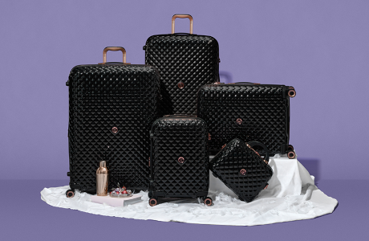

FEATURED DEAL
Name: Paint Nite

Offer Title: Up to 30% off

Redemption URL: https://go.launchingdeals.com/CCRQ8DF

Redeem Instructions: Click link and discount will automatically be applied

Offer Key: 469930076

Short Description: When you paint at a Paint Nite class, you aren’t just following along during some boring, paint-by-numbers situation. You’re putting your unique spin on one of their 36,000+ original design options with the expert guidance from a class instructor. And did we mention there’s wine? Because, there’s totally wine.

Logo: https://static.accessdevelopment.com/brand/e13e746c0e68b0b8232a202cf849b92957999cc8/PaintNite_Logo_300x300_06032025.png

Expiration Date: 6/30/2026

T&C: What's Included:
Valid towards in-person, virtual, and on-demand creative events, including the original Paint Nite®
Promotional value valid for 6 months from purchase.
In-person classes include project materials.
For virtual Paint Nite events, instructors recommend: six acrylic paints, three mixed-sized brushes, 11x14", 12x16" or 16x20" canvases, a mixing pallet, apron, tablecloth, and tabletop easel.
Promotional value expires 180 days after purchase. Amount paid never expires. 48-hour cancellation notice required. Reservations required; contact online at paintnite.com. Not valid in Canada. Must be of legal drinking age to consume alcohol, valid ID required. Customers under legal drinking age are only permitted at events marked for ages under 18. Value may be applied to any experience on paintnite.com. Tax may be collected at time of reservation in some areas based on local tax code. Not valid for special events or fundraiser events. Please note: Some events do not accept vouchers. Valid for events up to $45. Alcohol not included with admission; available for purchase at the bar. Additional experience fees may apply for materials, special events, and events in certain markets. Subject to availability. May buy multiples. Limit 10 per person. Merchant is solely responsible to purchasers for the care and quality of the advertised goods and services.
* Savings are based on average market prices in the US
All sales are final and non-refundable unless specified otherwise
Powered by Access. Valid only at the location listed. Only one offer may be redeemed per visit. Offer may not be valid with other sales/promotions. Void if altered, transferred, purchased or sold; use for these purposes is illegal and constitutes fraud. Other restrictions may apply. Offers are subject to change without notice. No cash value. © Access Development. All rights reserved. www.accessdevelopment.com



