FEATURED DEAL
Name: H&R Block®

Offer Title: Get 30% Off DIY Online Tax Filing with H&R Block.

Redemption URL: https://linkto.hrblock.com/c/24547/3719984/5683?prodsku=lob-gct_103_p11

Short Description: With so many ways to file at H&R Block, you'll find the right fit & savings for you. File virtually, via drop off, in person or online .

Logo: https://static.accessdevelopment.com/brand/cf55ccc518e0095cf6898afb2f2a7af28f71c1a8/HRBlock_18938611_03012022.png

Expiration Date: 03/31/2026

T&C: Powered by Access. Valid only at the location listed. Only one offer may be redeemed per visit. Offer may not be valid with other sales/promotions. Void if altered, transferred, purchased or sold; use for these purposes is illegal and constitutes fraud. Other restrictions may apply. Offers are subject to change without notice. No cash value. © Access Development. All rights reserved. www.accessdevelopment.com



FEATURED DEAL
Name: TurboTax

Offer Title: Save an extra 20% off TurboTax

Redemption URL: https://www.jdoqocy.com/click-7273667-16985172?sid=ADD_CVT

Short Description: File with total confidence knowing your tax return is protected for its full 7-year lifetime. Only TurboTax backs your taxes for the entire life of your return, guaranteeing 100% accurate calculations, your maximum refund, and full audit support. Whether you prepare your taxes yourself or our experts handle them for you, we guarantee complete accuracy, or we’ll pay any penalties. With TurboTax, your refund, your accuracy, and your peace of mind are all guaranteed for the full life of your tax return.

Logo: https://static.accessdevelopment.com/brand/1a53810ed4faf9a7e74914033942be27146ba423/TurboTax_18939424_01292024.png

Expiration Date: 03/31/2026

T&C: Check website for details. Powered by Access. Offer may not be valid with other sales/promotions. Void if altered, transferred, purchased or sold; use for these purposes is illegal and constitutes fraud. Other restrictions may apply. Offers are subject to change without notice. No cash value. © Access Development. All rights reserved. www.accessdevelopment.com



FEATURED DEAL
Name: E-file.com

Offer Title: 40% Off E-file.com Federal Income Tax Software

Redemption URL: https://www.tkqlhce.com/click-7273667-11917165?sid=ADD_CVT

Promo Code: ACCESS40

Short Description: E-file.com is an authorized IRS e-file software provider who helps taxpayers file their income taxes faster, easier and more accurately than with traditional paper forms. We provide online income tax software to U.S. taxpayers.

Logo: https://static.accessdevelopment.com/brand/da2eb94a40e8d5c0ce8ee8f5a9d26019eafa35b8/Efile_logo_300x300_12022024.png

Expiration Date: 03/31/2026

T&C: This discount applies to software only; it cannot be combined and must be used at the time of payment. Powered by Access. Valid only at the location listed. Only one offer may be redeemed per visit. Offer may not be valid with other sales/promotions. Void if altered, transferred, purchased or sold; use for these purposes is illegal and constitutes fraud. Other restrictions may apply. Offers are subject to change without notice. No cash value. © Access Development. All rights reserved. www.accessdevelopment.com



FEATURED DEAL
Name: Flex

Offer Title: Split your rent into two payments: Flex gives you access to a credit line so you can pay part of your rent later and breathe easier each month.

Redemption URL: https://flexiblefinance.pxf.io/c/24547/3220564/38980

Short Description: Split your rent into smaller more manageable payments that fit your budget—and your life.

Logo: https://static.accessdevelopment.com/brand/70a0879b88ff5da4773279dab92f6f6586afde0e/Flex_Logo_300x300_08202025.png

Expiration Date: 03/31/2026

T&C: Powered by Access. Valid only at the location listed. Only one offer may be redeemed per visit. Offer may not be valid with other sales/promotions. Void if altered, transferred, purchased, or sold; use for these purposes is illegal and constitutes fraud. Other restrictions may apply. Offers are subject to change without notice. No cash value. © Access Development. All rights reserved. www.accessdevelopment.com

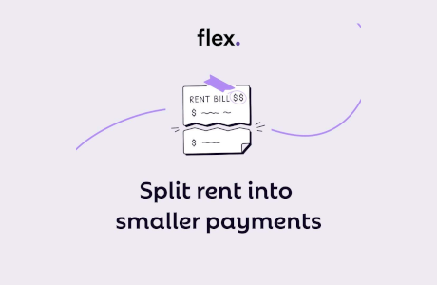

FEATURED DEAL
Name: Current

Offer Title: $50 bonus* with qualifying deposit.

Redemption URL: https://current.pxf.io/xkWvEx

Promo Code: ACCESS50

Short Description: We're on a mission to build the future of banking. That means finding a new way to do things. As a Current customer, enjoy fee-free overdraft protection and get paid up to 2 days faster with direct deposit. Get up to a $500 paycheck advance if you qualify.

Logo: https://static.accessdevelopment.com/brand/f218c2adfe61010e2afeb913ad2bcab89a76504e/Current_457600778.png

Expiration Date: 03/31/2026

T&C: New customers only.Actual overdraft amount may vary and is subject to change at any time, at Current’s sole discretion. In order to qualify and enroll in the Fee-Free Overdraft feature, you must receive $500 or more in Eligible Direct Deposits into your Current Account over the preceding 35-day period and fulfill other requirements subject to Current’s discretion. Negative balances must be repaid within 60 days of the first Eligible Transaction that caused the negative balance. For more information, please refer to https://current.com/overdraft_protection_terms_of_service/ Individual Current Accounts only.
Faster access to funds is based on comparison of traditional banking policies and deposit of paper checks from employers and government agencies versus deposits made electronically. Direct deposit and earlier availability of funds is subject to timing of payer's submission of deposits.
Paycheck Advance is for eligible customers only. Your actual available Paycheck Advance amount will be displayed to you in the mobile app and may change from time to time. Conditions and eligibility may vary and are subject to change at any time, at the sole discretion of Finco Advance LLC, which offers this optional feature. Finco Advance LLC is a financial technology company, not a bank. For more information, please refer to https://cdn.current.com/agreements/paycheck_advance_terms_v2.pdf"
*For more information, please refer to the Current Referral Program Terms and Conditions, https://current.com/referral_program_terms_and_conditions/
Current is a financial technology company, not an FDIC-insured bank. FDIC insurance up to $250,000 only covers the failure of an FDIC-insured bank. Certain conditions must be satisfied for pass-through deposit insurance coverage to apply. Banking services provided by Choice Financial Group, Member FDIC, and/or Cross River Bank, Member FDIC. The Current Visa® Debit Card, which may be issued by Choice Financial Group and/or Cross River Bank, and the Current Visa® secured charge card, which is issued by Cross River Bank, are all issued pursuant to licenses from Visa U.S.A. Inc. and may be used everywhere Visa debit or credit cards are accepted. A Current debit account is required to apply for the Current Visa® secured charge card. Independent approval required.
Powered by Access. Only one offer may be redeemed per visit. Offer may not be valid with other sales/promotions. Void if altered, transferred, purchased, or sold; use for these purposes is illegal and constitutes fraud. Other restrictions may apply. Offers are subject to change without notice. No cash value. © Access Development. All rights reserved. www.accessdevelopment.com



FEATURED DEAL
Name: Piere

Offer Title: 50% off your first year.

Redemption URL: https://piere.sjv.io/c/24547/3086526/26034?sharedid=ADD_CVT

Short Description: Piere enables users to effortlessly manage their finances with intuitive tools. Users can track expenses, manage budgets, and plan for the future—all within one sleek app. Start transforming your financial habits with Piere today.

Logo: https://static.accessdevelopment.com/brand/864a65b3b5300f41aaf9cb5ae7b30944f3a138cf/Piere_482734379.png

Expiration Date: 03/31/2026

T&C: New subscribers only. Only valid in the U.S. Powered by Access. Only one offer may be redeemed per visit. Offer may not be valid with other sales/promotions. Void if altered, transferred, purchased, or sold; use for these purposes is illegal and constitutes fraud. Other restrictions may apply. Offers are subject to change without notice. No cash value. © Access Development. All rights reserved. www.accessdevelopment.com



FEATURED DEAL
Name: IDShield

Offer Title: Personal Identity Theft Protection – Starting at $14.95/month

Redemption URL: https://idshield.pxf.io/c/24547/1668917/18219?subId1=ADD_CVT

Short Description: IDShield helps protect your online identity and personal information. A monthly subscription that monitors your credit, finances, and online reputation. Our dedicated investigators help restore identity and give you access to cyber security tools.

Logo: https://static.accessdevelopment.com/brand/42b589d5f800a0f60dad2b3781921103f9454f14/idshieldlogo.png

Expiration Date: 03/31/2026

T&C: Powered by Access. Valid only at the location listed. Only one offer may be redeemed per visit. Offer may not be valid with other sales/promotions. Void if altered, transferred, purchased, or sold; use for these purposes is illegal and constitutes fraud. Other restrictions may apply. Offers are subject to change without notice. No cash value. © Access Development. All rights reserved. www.accessdevelopment.com

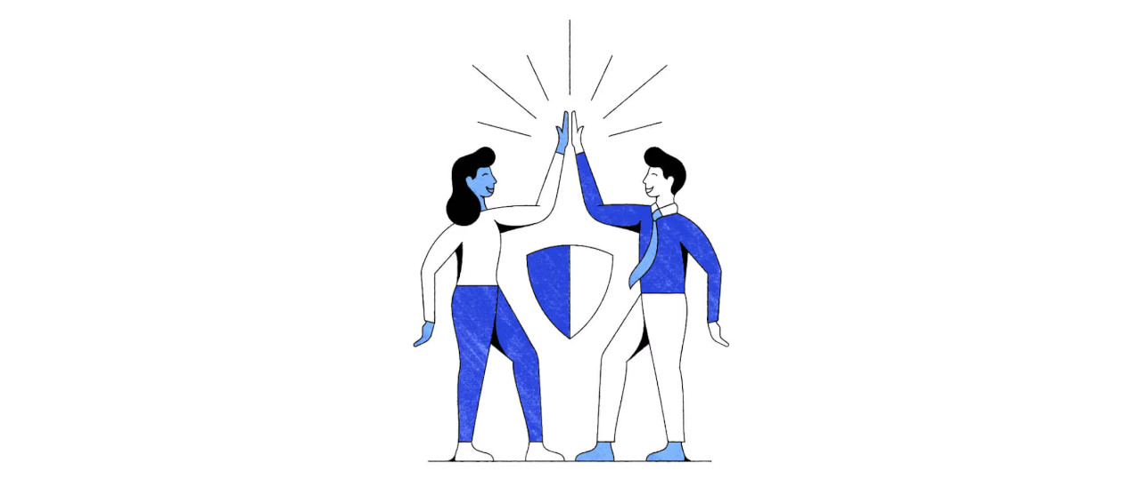

FEATURED DEAL
Name: LivingTrustify

Offer Title: 25% off any purchase.

Redemption URL: https://livingtrustifyllc.sjv.io/Wy3M1e

Promo Code: ACCESS25

Short Description: An online platform to help build a Living Trust or Will based estate plan. By answering around 15 questions in 15 minutes, customers can get an affordable estate plan to protect their assets and have peace of mind.

Logo: https://static.accessdevelopment.com/brand/f1f63e4e4bcefc7d722ff333d62c4045d7231843/LivingTrustify_Logo_300x300.png

Expiration Date: 03/31/2026

T&C: Not valid with any other offer. LivingTrustify LLC is not a law firm and does not provide legal advice. The purpose of the website is to allow users to generate self-help forms using an automated, proprietary system.<br><br>Powered by Access. Valid only at the location listed. Only one offer may be redeemed per visit. Offer may not be valid with other sales/promotions. Void if altered, transferred, purchased, or sold; use for these purposes is illegal and constitutes fraud. Other restrictions may apply. Offers are subject to change without notice. No cash value. © Access Development. All rights reserved. www.accessdevelopment.com



