FEATURED DEAL
Name: 1-800-FLOWERS

Offer Title: 20% off online purchases.

Redemption URL: https://www.1800flowers.com/flowers-and-gifts-promo-acceptable-11296?r=accessdev18f&utm_medium=bgs&utm_source=access_development&utm_campaign=stdoffer-web_email&utm_content=cmorris&utm_term=20p

Promo Code: AD20

Offer Key: 482219649

Short Description: Receiving a gift of fresh flowers is always a thrill, and 1-800-FLOWERS.COM makes sending that excitement to your loved ones easier than ever before! We make it simple to send flowers online, no matter what the occasion. You can explore an amazing selection of flowers and florist-designed flower arrangements right here online. We're devoted to delivering flowers that bring smiles. For that reason, we bring you flowers of the freshest and highest quality. When you send flowers from 1-800-FLOWERS.COM, you're sending flowers specially selected as the best blooms from the world's best growers.

Logo: https://static.accessdevelopment.com/brand/a5209804debd4f6ab9f916d0650b35644e7b6bc8/original.png

Expiration Date: 05/31/2026

T&C: Discount may not be applied for certain products. Discount will be applied after payment information is entered. You will be able to review your order and verify discount application before your card is charged. Exclusive of applicable service & shipping charges & taxes. Items may vary & are subject to availability & delivery rules & times. 20% offer available online and by phone only. In-Store offer: 15% off any in-store purchase of $29.99 or more. Plus, receive a free rose or free chocolate covered strawberry (where available). Offers cannot be combined, are not available on all products & are subject to restrictions, limitations & blackout periods. ©2020 1-800-FLOWERS.COM, INC. For full terms and conditions go here: https://www.1800flowers.com/disclaimer. Prices & charges are subject to change without notice. Void where prohibited. In-Store offer valid only at certain locations. Only one offer may be redeemed per visit. No cash value. Valid thru 12/31/2025. Powered by Access. Offer may not be valid with other sales/promotions. Void if altered, transferred, purchased or sold; use for these purposes is illegal and constitutes fraud. Other restrictions may apply. Offers are subject to change without notice. © Access Development. All rights reserved. www.accessdevelopment.com



FEATURED DEAL
Name: Kohl's

Offer Title: 15% off purchase of $100 or more.

Redemption URL: https://kohls.sjv.io/c/24547/1747446/5349?subId1=ADD_CVT

Promo Code: CATCH15OFF

Offer Key: 436826681

Short Description: Kohl's stores are stocked with everything you need for yourself and your home - apparel, shoes & accessories for women, children and men, plus home products like small electronics, bedding, luggage and more. Online, we've taken our commitment to convenience even further, and you'll find there's more to like at Kohls.com with every click of your mouse. We not only offer the best merchandise at the best prices, but we're always working to make your shopping experience enjoyable.

Logo: https://static.accessdevelopment.com/brand/7a464af9ffab28cdaa7a26b4f2d08dd197bba6e2/Kohls_logo_300x300.png

Expiration Date: 05/31/2026

T&C: Online Only. https://cs.kohls.com/app/answers/detail/a_id/1086/~/exclusions Click here for full list of exclusions. Offer not valid during Kohl's pricing events. Powered by Access. Offer may not be valid with other sales/promotions. Void if altered, transferred, purchased or sold; use for these purposes is illegal and constitutes fraud. Other restrictions may apply. Offers are subject to change without notice. © Access Development. All rights reserved. www.accessdevelopment.com



FEATURED DEAL
Name: Papa John's®

Offer Title: 20% off regular menu price online orders.

Redemption URL: https://www.papajohns.com/

Promo Code: 20OFFAD

Offer Key: 446087997

Short Description: Papa John's really delivers, because we are focused on quality pizza. And it starts with our Better Ingredients, like our fresh, never frozen, original dough, all natural-sauce, 100% real meats and fresh-sliced veggies. And, we think you'll taste the difference, because "Nobody does what Papa John's does." Order online today and use the pizza discount from Access! We always have pizza specials and deals.

Logo: https://static.accessdevelopment.com/brand/999ce26681cb7ec08d0fe1f32a777073d025a950/PapaJohn's_Logo_04202026.png

Expiration Date: 05/31/2026

T&C: Offer good online only for regular menu price items for a limited time at participating U.S. Papa Johns restaurants. Not valid with any other coupons or discounts. Limited delivery area. Delivery fee may apply and is not subject to discount offer. Customer responsible for all applicable taxes. ©2024 Papa John's International, Inc. All Rights Reserved. Powered by Access. Valid only at the location listed. Only one offer may be redeemed per visit. Offer may not be valid with other sales/promotions. Void if altered, transferred, purchased or sold; use for these purposes is illegal and constitutes fraud. Other restrictions may apply. Offers are subject to change without notice. No cash value. © Access Development. All rights reserved. www.accessdevelopment.com
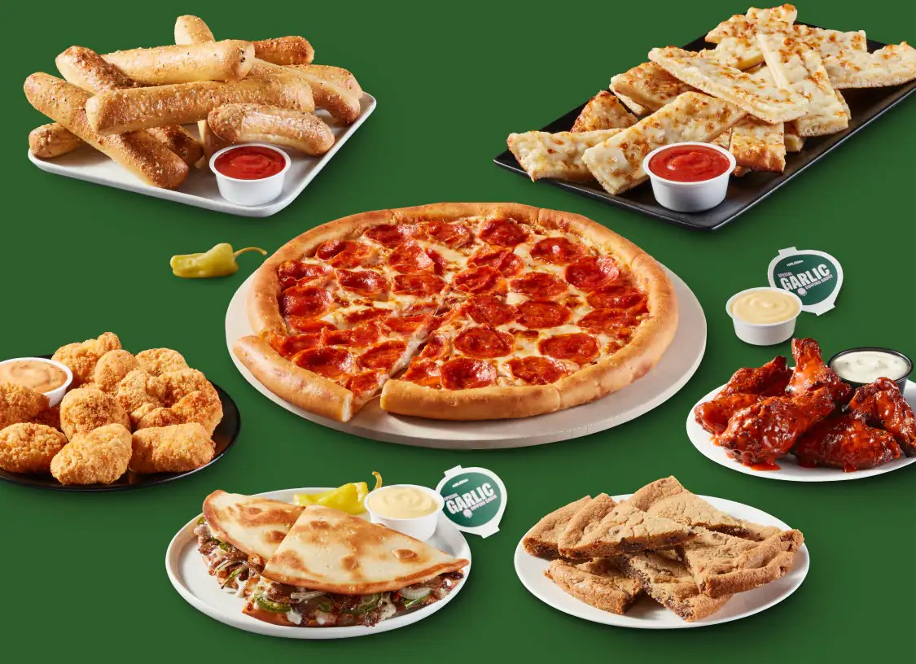

FEATURED DEAL
Name: Darden Restaurants Gift Cards

Offer Title: $5 off $50 eGift Card purchase.

Redemption URL (add this to the end of your savings program URL): /director?view=offer&offer_key=473186429

Offer Key: 473186429

Short Description: Our family of restaurants features some of the most recognizable and successful brands in full-service dining. Whether creating everyday memories or celebrating a special occasion, we host life’s big and small moments. In each of our 2,100-plus locations, we strive to create exceptional dining experiences by focusing on culinary innovation and execution, attentive service, and engaging and inviting atmospheres.

Logo: https://static.accessdevelopment.com/brand/c5735a490540176c083a8cbaf4987e03f768b06b/DardenRestaurants_473173971.png

Expiration Date: 05/31/2026

T&C: Gift card is only valid in the United States. A $2 processing fee will be added to each card ordered. Your purchase, use or acceptance of this Gift Card constitutes acceptance of the following terms and conditions. This Gift Card is issued by and represents an obligation solely of Darden SV, Inc. (“Darden”). Each time you use it, we’ll deduct that amount from the balance until you’ve used the full balance of the card. (1) Except where required by law, this gift card is not redeemable for cash. (2) We can’t replace the value on this card it if it’s lost or stolen. (3) It may be redeemed at any Darden restaurant but are only valid in participating locations in the United States. (4) Darden approval required to advertise this card. (5) May not be used to purchase alcohol where prohibited by law. (6) Gift Card does not expire. (7) Gift card deemed purchased from and issued in the State of Florida. (8) The risk of loss and title to the Gift Card passes to the recipient upon electronic transmission of the Gift Card. (9) Gift Card balance may not be transferred to a physical gift card; however, electronic gift card may be printed or reprinted for redemption. For Gift Card balance and activity visit www.olivegarden.com or call toll-free 1-877-230-4120. ©2024 Darden Concepts, Inc.
Powered by Access. Valid only at the location listed. Only one offer may be redeemed per visit. Offer may not be valid with other sales/promotions. Void if altered, transferred, purchased or sold; use for these purposes is illegal and constitutes fraud. Other restrictions may apply. Offers are subject to change without notice. No cash value. © Access Development. All rights reserved. www.accessdevelopment.com

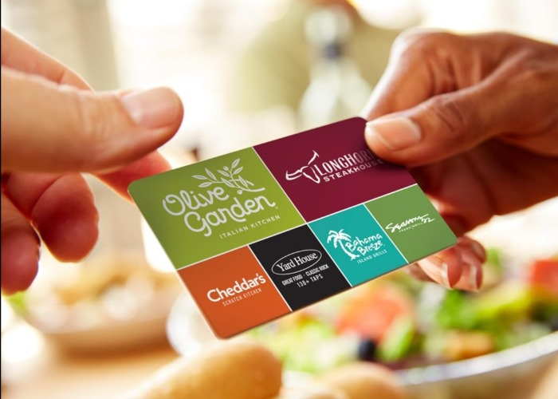

FEATURED DEAL
Name: minted

Offer Title: Enjoy 21% off your first order + 11% off art

Redemption URL: https://mintedllc.sjv.io/c/24547/3227884/19909?subId1=ADD_CVT

Promo Code: ACCESS

Offer Key: 474476702

Short Description: Minted is an online design marketplace of unique stationery, art, decor, and more created by a global community of over 16,000 artists.

Logo: https://static.accessdevelopment.com/brand/8743c26dc48e8b6da550ba05bbc13a342cee06f7/minted456802781_logo_300x300.png

Expiration Date: 05/31/2026

T&C: Powered by Access. Valid only at the location listed. Only one offer may be redeemed per visit. Offer may not be valid with other sales/promotions. Void if altered, transferred, purchased or sold; use for these purposes is illegal and constitutes fraud. Other restrictions may apply. Offers are subject to change without notice. No cash value. © Access Development. All rights reserved. www.accessdevelopment.com



FEATURED DEAL
Name: Harry & David

Offer Title: 15% off with no minimum purchase.

Redemption URL: http://harryanddavid.sjv.io/c/24547/369374/5371

Promo Code: AD20

Offer Key: 407445497

Short Description: Delicious since 1934. Harry and David offers an extensive collection of gourmet gifts designed to delight all, including gift baskets filled with gourmet foods, Royal Riviera pears, chocolates, and much more!

Logo: https://static.accessdevelopment.com/brand/be2596c86ca6f017acfdec49b041d479c236412f/original.png

Expiration Date: 05/31/2026

T&C: Not valid for the purchase of gift cards, red-tag clearance items, or products containing alcohol; cannot be used in combination with other discounts or promotion; and cannot be applied to previous purchases or applicable taxes. Void where prohibited by law. Not valid with catalog, in-store, or phone orders. Void if transferred, copied, purchased, sold, or bartered. No cash value. Powered by Access. Valid only at the location listed. Only one offer may be redeemed per visit. Offer may not be valid with other sales/promotions. Void if altered, transferred, purchased or sold; use for these purposes is illegal and constitutes fraud. Other restrictions may apply. Offers are subject to change without notice. No cash value. © Access Development. All rights reserved. www.accessdevelopment.com



FEATURED DEAL
Name: Nekter Juice Bar

Offer Title: Buy One Get One 50% Any Bowl

Redemption URL: http://onelink.to/nekter

Redemption Instructions: How to Redeem This Offer:
1. Open the Nekter Juice Bar App. If you don't already have it download it on Google Play, or the Apple Store.
2. Sign into the app. Create your order for Pick Up or Delivery. Click the "Redeem Coupon Code” on the checkout screen, enter promotion code into the box and click "ADD".
3. Complete your order.

Promo Code: ACCESSBOWL226

Offer Key: 479926866

Short Description: New Nékter Loyalty App Members get a Free Smoothie or Juice after your first purchase! Download the app now to unlock exclusive deals, skip the line, and save time. Nekter Juice Bar is the pioneer of the modern juice bar experience with a delicious menu of fresh juices, Superfood smoothies, acai bowls, and healthy snacks that is 100 percent, freshly made, clean, nutrient-rich and can be customized based on individual diet or lifestyle preferences, such as vegan, vegetarian, gluten-free, and low-sugar. With an unwavering commitment to ingredient transparency, authenticity and innovation, Nekter Juice Bar is rooted in the philosophy that "healthy" can taste great, be easily accessible, and be affordable too. Come see why we are the top-rated juice places, smoothie shops, and have the best acai bowls in town!

Logo: https://static.accessdevelopment.com/brand/49b7d0be1861f78e7825b75e95a8b06892885380/Nekter_Logo_300x300_05192025.png

Expiration Date: 05/31/2026

T&C: Check back quarterly for a new code. This offer is valid from 4/1/26 - 6/30/26, enter promo code in the Nékter Loyalty App at check-out to unlock Buy One Get One 50% Any Acai Bowl. To use, apply Reward at checkout for Orders including any (2) Bowls at participating locations. Single use. Not valid with third-party delivery. Void where prohibited.
Powered by Access. Valid only at the location listed. Only one offer may be redeemed per visit. Offer may not be valid with other sales/promotions. Void if altered, transferred, purchased or sold; use for these purposes is illegal and constitutes fraud. Other restrictions may apply. Offers are subject to change without notice. No cash value. © Access Development. All rights reserved. www.accessdevelopment.com

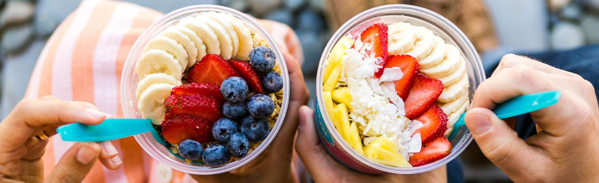

FEATURED DEAL
Name: Mrs. Fields®

Offer Title: Receive 20% off Your First Order with Email Sign Up

Redemption URL: https://fmtc.co/48042740/d99f47ec361410ac5ecb5c798fb641d1?sid=ADD_CVT

Offer Key: 464743758

Short Description: From one small store in Palo Alto, California, to an internationally recognized brand, Mrs. Fields Cookies has won universal acclaim as the world’s premier chain of cookies shops, offering a singularly indulgent experience time and time again. Our motto "Good Enough Never Is®" reflects our uncompromising dedication to the consumers’ experience. Our signature products include tempting cookies, brownies and muffins, which are baked continuously and served warm and fresh at each of our locations. For over 20 years Mrs. Fields cookies have brought smiles to faces around the world!

Logo: https://static.accessdevelopment.com/brand/b735d99040b14c9d43dc01558adc36d48cfca0fb/MrsFieldsLogo_300x300.png

Expiration Date: 05/31/2026

T&C: Terms and Exclusions Apply, See Site for Details. Powered by Access. Valid only at the location listed. Only one offer may be redeemed per visit. Offer may not be valid with other sales/promotions. Void if altered, transferred, purchased or sold; use for these purposes is illegal and constitutes fraud. Other restrictions may apply. Offers are subject to change without notice. No cash value. © Access Development. All rights reserved. www.accessdevelopment.com

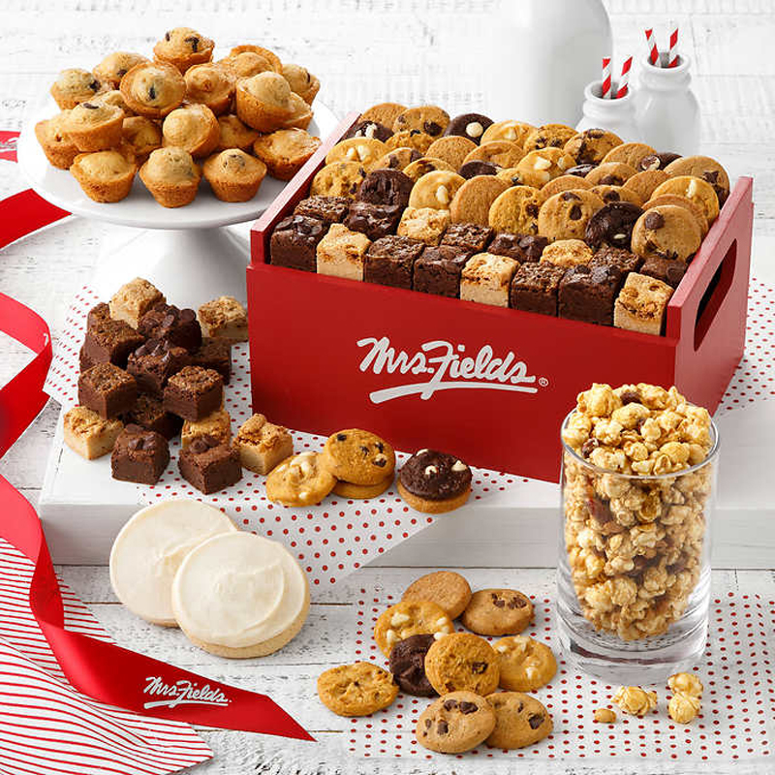

FEATURED DEAL
Name: Spafinder

Offer Title: 15% off gift card orders of $80 or more.

Redemption URL: https://click.linksynergy.com/fs-bin/click?id=jKsH%2fgT1ItI&offerid=776994.65&type=3&subid=ADD_CVT

Promo Code: VITALITY

Offer Key: 471452095

Short Description: Great last minute gift idea. SpaFinder gift certificates can be emailed. This is a great gift idea if you have someone you'd like to send a gift to in another state. Also - SpaFinder gift certificates can be printed at home. No need to wait to receive something in the mail.

Logo: https://static.accessdevelopment.com/brand/09abf5c069c1699f11b6735b8707cd8dcf06b904/SpafinderLogo300x300.png

Expiration Date: 05/31/2026

T&C: Valid on gift card purchases only. Cannot be combined with any other promos/offers. Powered by Access. Valid only at the location listed. Only one offer may be redeemed per visit. Offer may not be valid with other sales/promotions. Void if altered, transferred, purchased or sold; use for these purposes is illegal and constitutes fraud. Other restrictions may apply. Offers are subject to change without notice. No cash value. © Access Development. All rights reserved. www.accessdevelopment.com



FEATURED DEAL
Name: Zazzle

Offer Title: 15% off Sitewide

Redemption URL: https://fmtc.co/48475426/d99f47ec361410ac5ecb5c798fb641d1?sid=ADD_CVT

Promo Code: ZFILLIATEAPR26

Offer Key: 484014942

Short Description: Zazzle is a marketplace where you can customize anything from invitations to lamps to iPhone cases. Choose one of the millions of existing designs or create your own. With Zazzle, you can add a personal touch to your favorite products, which make for great gifts and everlasting memories.

Logo: https://static.accessdevelopment.com/brand/e0674018b62d90e2ecb7f26eb467b9796bedb467/original.png

Expiration Date: 05/31/2026

T&C: Powered by Access. Valid only at the location listed. Only one offer may be redeemed per visit. Offer may not be valid with other sales/promotions. Void if altered, transferred, purchased or sold; use for these purposes is illegal and constitutes fraud. Other restrictions may apply. Offers are subject to change without notice. No cash value. © Access Development. All rights reserved. www.accessdevelopment.com
